**EPON OLT Products User Manual**

**FD1204S/FD1208S/FD1216S/FD8000-L116**

**---Quick Configuration Guide**

**Version：V1.3**

**©Statement**Copyright ©2019 Shenzhen C-Data Technology Co., Ltd. All Rights Reserved. No part of this manual may be reproduced or transmitted in any form or by any means without the prior written consent.

The information in this document may be update at any time due to productversions upgrade or any other reasons. Unless otherwise agreed, this manual is for reference only. All statements, information and recommendations in this manual do not constitute the warranty of any kind, express or implied.

Please contact your suppliers to get the latest version of this document,thank you！

**About This Manual**

This manual is applicable to C-Data FD1204S、FD1208S、FD1216S、FD8000-L116 EPON OLT products quickly installation configuration guide, Is the user to quickly and easily manage EPON OLT equipment should read the information before guidelines.

The related documents for EPON OLT device are:  
《FD1204S/FD1208S/FD1216S/FD8000-L116 User Manual-Device Installation User Manual》

《FD1204S/FD1208S/FD1216S/FD8000-L116 User Manual- CLI Operation User Manual》

《FD1204S/FD1208S/FD1216S/FD8000-L116 User Manual- Configuration Guide》

**Content**

1 Instruction 1

Document Scope 1

Revision History 1

Proper Noun 1

Note 2

2 OLT Login Manage 2

2.1 OLT Login Manage Explanation 2

2.2 OLT Login By Console 2

2.3 OLT Login By Telnet 3

3 OLT Upgrade Method 4

4 OLT WEB Access Management Installation Method 6

5 Configure Service In OLT Discrete Mode（Non-Template）---CLI Command Method 7

5.1 FTTH Service Topology 8

5.2 Data Plan 8

5.3 Config Guide 8

5.4 Configure OLT Service 9

5.4.1 Configure OLT Global Vlan 9

5.4.2 Configure OLT GE Port Service Vlan 9

5.4.3 Configure OLT PON Port Service Vlan 11

5.4.4 Configure OLT Multicast Service 12

5.5 Check ONU Register Status. 12

5.6 Configure Bridge ONU(SFU) Service 12

5.6.1 Configure Bridge Onu(SFU) Internet Service 12

5.6.2 Configure Bridge Onu(SFU) Multicast Service 13

5.7 Configure Gateway ONU（HGU）Service 14

5.7.1 Configure Gateway ONU（HGU）Internet Service--RTK Solution 14

5.7.2 Configure Gateway ONU（HGU）Multicast Service--RTK Solution 15

5.7.3 Configure Gateway ONU（HGU）Internet Service--ZTE Solution 16

5.7.4 Configure Gateway ONU（HGU）Multicast Service--ZTE Solution 18

5.7.5 Configure Gateway ONU（HGU）VOIP Service--ZTE Solution 20

6 Configure Service In OLT Profile Mode---CLI Command Method 23

6.1 Data Plan 23

6.2 Configure Process 23

6.3 Configure OLT Service 24

6.3.1 Configfure OLT Globle Vlan 24

6.3.2 Configure OLT GE Port Service Vlan 24

6.3.3 Configure OLT PON Port Service Vlan 25

6.3.4 Configure OLT Multicast Service 25

6.4 Create ONU Profile 26

6.4.1 Create ONU DBA Profile 26

6.4.2 Create ONU Lineprofile 26

6.4.3 Create ONU Srvprofile 27

6.5 Add ONU Manually 27

6.6 Check ONU Registration Status 27

6.7 Configure Bridge ONU（SFU）Service 28

6.7.1 Configure Bridge ONU(SFU) Internet Service 28

6.7.2 Configure Bridge ONU(SFU) IPTV Service 29

6.8 Gateway ONU（HGU）Service Configure Introduction 29

7 Configure OLT QinQ Service 30

7.1 Data Plan 30

7.2 Configure Processes 30

7.3 Configure OLT 31

8 Common Command Description 31

9 Configure Service In OLT Discrete Mode（Non-Template）---EMS Method 32

9.1 Data Plan 32

9.2 Configuration Guide 32

9.3 Configure OLT Service 33

9.3.1 Configure OLT Global Vlan 33

9.3.2 Configure OLT GE Port Service Vlan 34

9.3.3 Configure OLT PON Port Service Vlan 36

9.3.4 Configure OLT Multicast Service 37

9.4 Configure Bridge ONU(SFU) Service 40

9.4.1 Configure Bridge Onu(SFU) Internet Service 40

9.4.2 Configure Bridge Onu(SFU) Multicast Service 41

10 Configure Service In OLT Discrete Mode（Non-Template）---WEB Method 43

10.1 Data Plan 43

10.2 Configuration Guide 43

10.3 Configure OLT Service 44

10.3.1 Configure OLT Global Vlan 44

10.3.2 Configure OLT GE Port Service Vlan 45

10.3.3 Configure OLT PON Port Service Vlan 46

10.3.4 Configure OLT Multicast Service 48

10.4 Configure Bridge ONU(SFU) Service 50

10.4.1 Configure Bridge Onu(SFU) Internet Service 50

10.4.2 Configure Bridge Onu(SFU) Multicast Service 51

Concluding Remarks 53

# Instruction

## Document Scope

|  |  |  |  |
| --- | --- | --- | --- |
| **Reading Object** | **Product** | **Products Software Version** | |
| C-DATA Employees,  FTTX Operation&Maintenance Engineer,  C-DATA Customer’s Technical Engineer | Cdata EPON OLT（FD1204S/FD1208S /FD1216S/FD8000-L116） | V1.3.X | |
| Compiling Department | C-Data Product Management Center Technical Support Department | Document Version | V1.3 |

## Revision History

|  |  |  |  |
| --- | --- | --- | --- |
| **Date** | **Version** | **Description** | **Author** |
| 2017-12-7 | V1.1 | OLT version switch to V1.2.X, cli command line have been changed.,update config guide fully | Technical Support  Department |
| 2018-3-4 | V1.2 | 1.OLT version switch to V1.3.X, cli command line have been changed,update config guide fully  2.Add FD8000-L116 config instruction | Technical Support  Department |
| 2019-02-13 | V1.3 | 1.Add OLT EMS and WEB management type config guide  2.Add how to access the OLT web management | Technical Support  Department |

## Proper Noun

|  |  |  |
| --- | --- | --- |
| Acronym | Full name | Instructions |
| EPON | Ethernet Passive Optical Network | Ethernet Passive Optical Network |
| OLT | Optical Line Terminal | Optical Line Terminal |
| ONU | Optical Network Unit | Optical Network Unit |
| OMCI | ONU Management and Control Interface | GPON OLT&ONU Management and Control Interface(protocol) |
| OAM | Operation Administration and Maintenance | EPON OLT&ONU Operation Administration and Maintenance Protocol |
| DBA | Dynamic Bandwidth Allocation | Dynamic Bandwidth Allocation |
| VLAN | Virtual Local Area Network | Virtual Local Area Network |
| VoIP | Voice over IP | Voice over IP |
| WLAN | Wireless Local Area Networks | Wireless Local Area Networks |
| FTTH | Fiber To The Home | Fiber To The Home |
| FTTB | Fiber To The Building | Fiber To The Building |

## Note

* The command line described in the document is case sensitive in OLT.
* If we meet a command that cannot be inputed or is prompted for error,we can input **“?”** to see the latter command format.
* Input incomplete commands can be completed by pressing the **“Tab”** key.
* FD1204S、FD1208S、FD1216S are Pizza-Box OLT，only have one card，so,if we want to enter PON mode,need input interface epon 0/0
* FD8000-L116 is Plug-in card OLT,has four PON card,so the comamnd for entering PON mode is OLT(config)# interface epon 0/**<SlotID>** ,SlotID is Slot Number,range is 1-4，for example,the command for entering slot 1 is OLT(config)# interface epon 0/1

# OLT Login Manage

## OLT Login Manage Explanation

FD1204S、FD1208S、FD1216S support CLI,EMS and WEB management;CLI manege type divided into telnet remote manage and console local manage, please check #2.2 and #2.3 chapter to see concrete operations;please check EMS user manual to see EMS manage way;please check #4 to see WEB manage way.

## OLT Login By Console

First,find console port on OLT front surface,which is a RJ45 port.if want to login OLT by Console port,we need do prepare as follows:

* Need RJ-45-to-DB-9 serial line
* Connect PC to OLT concole port,find COM number in **“computer management”**
* Software for logining OLT by console port(Putty,SecureCRT)
* [parameter](http://dict.youdao.com/w/parameter/" \l "keyfrom=E2Ctranslation) for console login software

Baud Rate:9600

Parity Check:None

Databit:8

Stopbit:1

Flow Control:None

Login OLT by console login software,then input **username:root,password:admin**

**[OLT console connection diagram]**

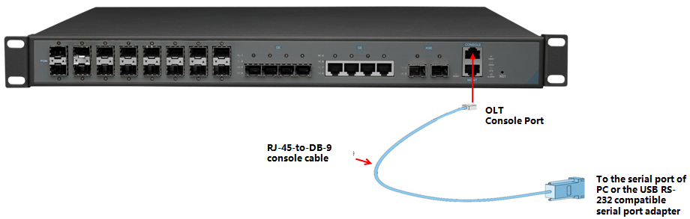

**[OLT console connection device]**

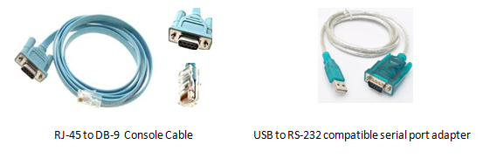

| **Port on Computer** | **Required Cable** | **Port on OLT** |
| --- | --- | --- |
| Serial Port | RJ-45 to DB-9 Console Cable | RJ-45 Console Port |
| USB Type-A Port | * USB to RS-232 compatible serial port adapter ( Adapter may require a software driver ) * RJ-45 to DB-9 Console Cable |

## OLT Login By Telnet

**There are two way to telnet,one is outband management,another is inband management.**

1. **Outband management(connect OLT MGMT port)**

set PC ip as 192.168.1.X(except 192.168.1.100),PC connect to OLT MGMT port, login the OLT with OLT default manage IP (default IP : 192.168.1.100). then input username and password,default login username is root,password is admin.

**Use command as follow can modify the outband management IP:**

OLT> enable

OLT# config

OLT(config)# interface mgmt

OLT(config-interface-mgmt)# ip address 192.168.5.100 24

OLT(config-interface-mgmt)# exit

1. **Inband management(connect OLT ge port)**

First we login olt via console port or mgmt port, and add a vlanif for inband management, assigned an IP address to this vlan,add the ge port to the vlan,ge port vlan mode can be access or trunk,which depend on your network environment,then pc connect to OLT ge port（ge1-ge8） and telnet to the OLT.

**The way to set inband mangement ip as follows：**

OLT> enable

OLT# config

OLT(config)# vlan 100

OLT(config)# interface ge

OLT(interface-ge)# vlan access 5 100 **----configure ge 5 as inband management port**

OLT(interface-ge)# exit

OLT(config)# interface vlanif 100

OLT(interface-vlanif-100)# ip address 192.168.2.100 255.255.255.0

OLT(interface-vlanif-100)# exit

# OLT Upgrade Method

**1.Set up OLT update topology:**

Use a PC as FTP server(run wftpd32.exe or Wftpd.exe in this pc),and connect to OLT mgmt port or ge port to transmit firmware.

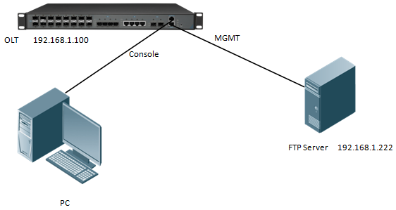

**2.Test network connectivity**

**a.**Connnect PC to OLT console port,used for updating OLT in boot mode.

**b.**Connect pc to OLT MGMT port or ge port,configure PC ip and OLT ip(inband ip or outband ip) are in same segment.

**c.**PC can ping OLT manegemnet IP,if pc can ping OLT manegemnet ip,means OLT can connect to FTP server.

**d.**Close PC firewall,prevent firewall intercept FTP software.

**3. FTP server configuration**

**a.**Open FTP software,configure FTP username and password,**such as**:admin/admin

**b.**Set up a directory of OLT updade files for the FTP server, such as the way for setting up the wftp32. Exe software：

---Security -> User/Rights Security Dialog -> User Name —input admin

---Change Password —input admin

---Home Directory —set directory of OLT upgrade files

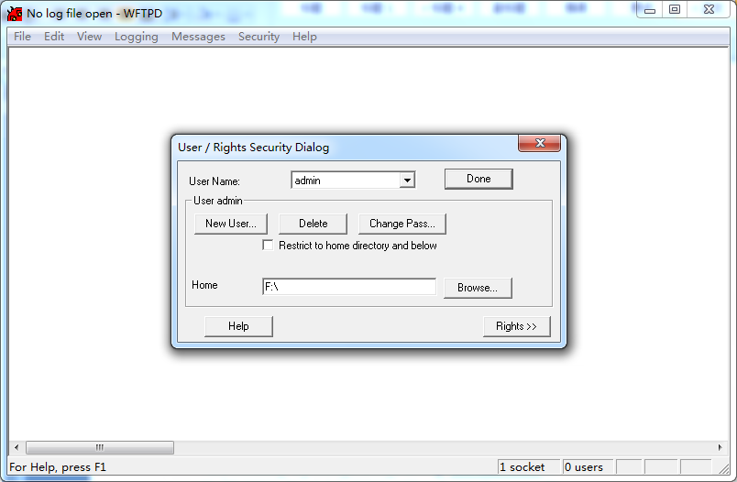**4.OLT update command**

FD1216S、FD1208S、FD1204S、FD8000-L116 OLT need update two file,one is FW file,another is Kernel file;if the boot file is too old,we need update boot file in OLT boot mode,boot upgrade way will be provided separately.OLT the common upgrade method please see below:

**a.Enter config view,input command as follows to update OLT kernel file(file name include Kernel )**

OLT(config)# load packetfile ftp 192.168.1.222 admin admin FD1216S_Kernel_X000_171114

_1833.img

Broadcast message from root:

Upgrade is in process.

File [FD1216S_Kernel_X000_171114_1833.img] download .......... OK

File [FD1216S_Kernel_X000_171114_1833.img] upgrade .......... OK

**b.Input command as follows to update OLT FW file(file name include FW )：**

OLT(config)# load packetfile ftp 192.168.1.222 admin admin FD1216S_FW_V1.3.1_X000_171

114_1841.img

Broadcast message from root:

Upgrade is in process.

File [FD1216S_FW_V1.3.1_X000_171114_1841.img] download .......... OK

File [FD1216S_FW_V1.3.1_X000_171114_1841.img] upgrade .......... OK

**5.After update OLT,we need reboot OLT(Note:only reboot OLT,OLT can use new version)**

OLT(config)# reboot

Please check whether data has saved, the unsaved data will lose if reboot system. Are you sure to reboot system? (y/n)[n]:y

# OLT WEB Access Management Installation Method

1.First, update the WEB firmware via the #3 OLT upgrade way,(firmware name include Web word

,such as FD1216S_Web_V1.0.1_X000_171114_1841.img)

OLT(config)# load packetfile ftp 192.168.1.222 admin admin FD1216S_Web_V1.0.1_X000_171114_1841.img

2.PC connect to OLT mgmt port or inband management port,make sure PC can ping OLT inband management ip or outband management ip

3.Before accessing OLT's web management from a PC, you need to enable OLT's SNMP functionality by the OLT command line.The configuration command is as follows:

OLT(config)# snmp-agent enable

OLT(config)# snmp-agent community read public

OLT(config)# snmp-agent community write private

4.After the OLT WEB firmware upgrade,can use below method check the OLT if have the web firmware version informaton,if see the information on the OLT,this mean the OLT have the web firmware version:

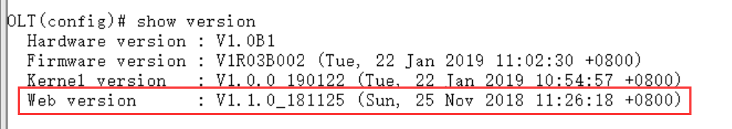

5.Open PC browser input OLT management ip,then we can see web login interface,web login username and password is admin/admin：

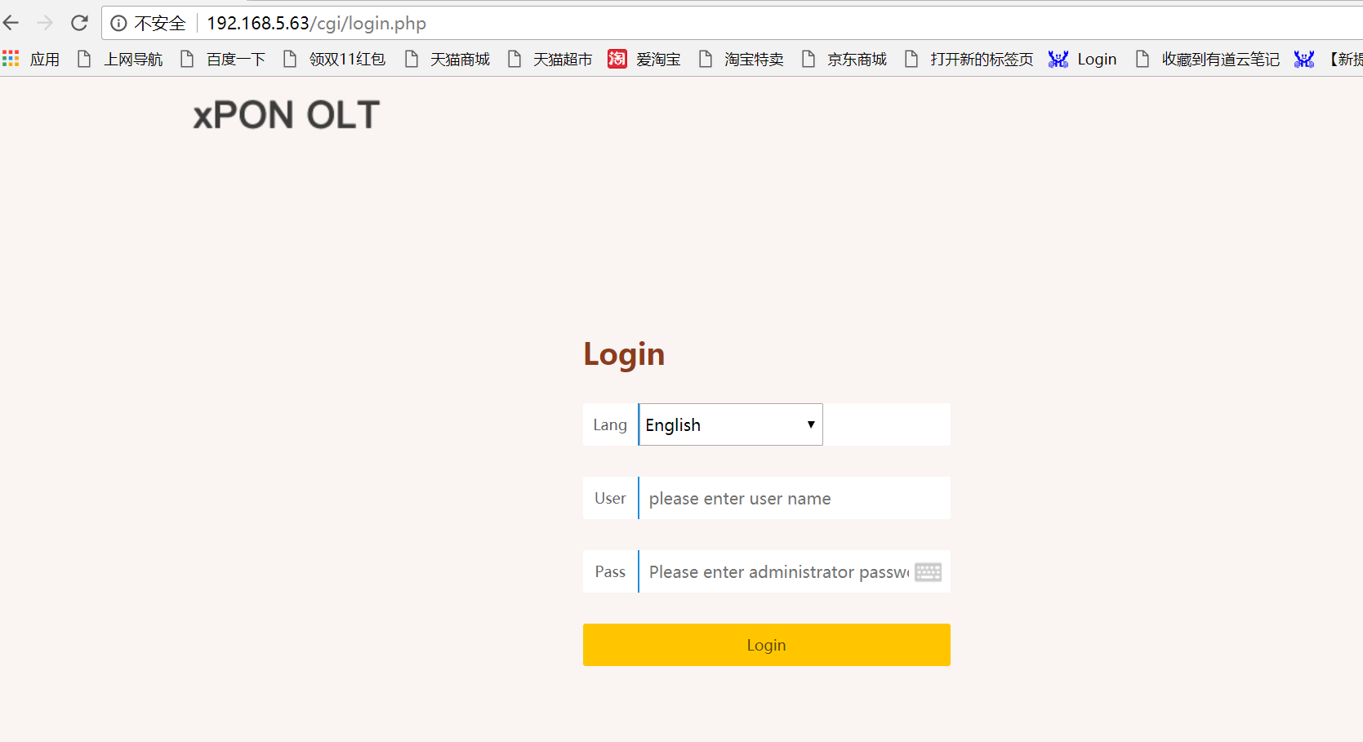

# Configure Service In OLT Discrete Mode（Non-Template）---CLI Command Method

This section mainly introduct FD1204S、FD1208S、FD1216S、FD8000-L116 internet service, voice service and multicast service in discrete mode in FTTH environment.Mainly introduce the bridge ONU(SFU and Home Gateway ONU (HGU),The following will introduce the service configuration way for OLT and ONU according to two types ONU.

## FTTH Service Topology

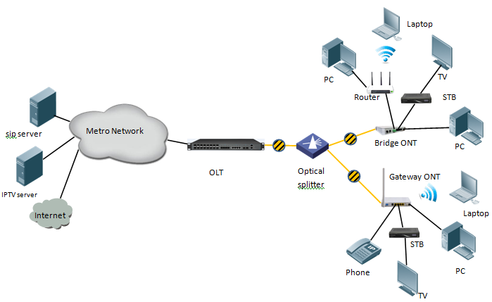

## Data Plan

|  |  |
| --- | --- |
| **Main Data Plan List** | |
| **Configuration Item** | **Data** |
| **VLAN Data** | VLAN 100：Internet Service  VLAN 200：IPTV Service  VLAN 300：VOIP Service |
| **OLT Port Setting** | Ge5：VLAN 100 access mode  Ge6：VLAN 200 access mode  Ge7：VLAN 300 access mode  PON1：VLAN 100, VLAN 200, VLAN 300 trunk mode |
| **ONU Register ID** | Bridge ONU ID：1  Gateway ONU ID：2 |
| **Bridge ONU Port config** | LAN 1：VLAN 100  LAN 2：VLAN 200  LAN3: VLAN 300 ---connect to VOIP phone |
| **Gateway ONU Port config** | Internet WAN：VLAN 100  IGMP WAN：VLAN 200  VOIC WAN：VLAN 300 |

## Config Guide

Create OLT Global Vlan

Create OLT GE Port Vlan

Create OLT PON port vlan

Create ONU Port Vlan

Save OLT Configration

Start

End

## Configure OLT Service

### Configure OLT Global Vlan

In **config** mode,we can use **OLT(config)# show vlan all** to show the created vlan.

If the created vlan can’t meet the need,we can use command **OLT(config)# vlan** vlan-list to create new vlan,According to the data plan, we create vlan100,vlan200,vlan300 firstly:

OLT(config)# vlan 100

OLT(config)# vlan 200

OLT(config)# vlan 300

### Configure OLT GE Port Service Vlan

We can config GE port vlan mode as access,hybrid and trunk,we can configure different mode according to our network plan, configure way of three mode as follows.

**Configure GE 5,6,7 port vlan mode is access(in this document,GE port connect to PC,so we configure ge port vlan mode as access):**

OLT(config)# **interface ge 0/0**

OLT(config-interface-ge-0/0)# **vlan mode 5-7 access**

OLT(config-interface-ge-0/0)# **vlan access 5 100**

OLT(config-interface-ge-0/0)# **vlan access 6 200**

OLT(config-interface-ge-0/0)#**vlan access 7 300**

OLT(config-interface-ge-0/0)# **exit**

**Configure GE 5、6、7口vlan mode is trunk：**

OLT(config)# **interface ge 0/0**

OLT(config-interface-ge-0/0)# **vlan mode 5-7 trunk**

OLT(config-interface-ge-0/0)# **vlan trunk 5 100**

OLT(config-interface-ge-0/0)# **vlan trunk 6 200**

OLT(config-interface-ge-0/0)#**vlan trunk 7 300**

OLT(config-interface-ge-0/0)# **exit**

**Configure GE 5、6、7口vlan mode is hybrid：**

OLT(config)# **interface ge 0/0**

OLT(config-interface-ge-0/0)# **vlan mode 5-7 hybrid**

OLT(config-interface-ge-0/0)# **vlan hybrid 5 tagged 100**

OLT(config-interface-ge-0/0)# **vlan hybrid 6 tagged 200**

OLT(config-interface-ge-0/0)# **vlan hybrid 7 tagged 300**

OLT(config-interface-ge-0/0)# **exit**

icon-note **NOTE：**

The OLT vlan handle process as follows:

|  |  |  |  |
| --- | --- | --- | --- |
| **Vlan mode** | **Direction** | **Message have vlan tag or not** | **Handling method** |
| **Access mode** | **In** | **vlan tag** | Discard |
| **untag** | Add port configured vlan in access mode for message (main parameter is VID),and forword |
| **Out** | **vlan tag** | Forward message to the corresponding port according to VID and remove vlan tag;If the VLAN ID of the Tagged message is not same to the port VID, it is discard. |
| **untag** | Discard |
| **Trunk mode** | **In** | **vlan tag** | If the VLAN in the message is permit to pass port, it will be forwarded directly; If the VLAN in the message doesn’t permit to pass port, it is discarded. |
| **untag** | Add default vlan(native-vlan) for untagged message and forward. |
| **Out** | **vlan tag** | If the VLAN in the message is permit to pass port, it will be forwarded directly; If the VLAN ID of the message is the default (native- VLAN)VLAN, then the VLAN tag is discard and forward;If the VLAN in the message doesn’t permit to pass port, it is discarded. |
| **untag** | Discard |
| **Hybrid mode** | **In** | **vlan tag** | If the VLAN in the message is permit to pass port, it will be forwarded directly; If the VLAN in the message doesn’t permit to pass port, it is discarded. |
| **untag** | Add default vlan(native-vlan) for untagged message and forward. |
| **Out** | **vlan tag** | If the VLAN in the message is permit to pass port,according vlan tag or vlan untag of message to discard or no discard vlan tag,then forward message,If the VLAN ID of the message is the default (native-VLAN) VLAN, then the VLAN tag is discard and forward; If the VLAN in the message doesn’t permit to pass port, it is discarded. |
| **untag** | Discard |

### Configure OLT PON Port Service Vlan

We can config PON port vlan mode as access,hybrid and trunk,according to our network plan configure different mode,if message from ONU is untag,we can configure PON port vlan mode is access or hybrid untag mode;if message from ONU is tag,we can configure PON port vlan mode is trunk or hybrid tag mode; configure way as follows.

**Config PON1 port vlan mode is access:**

OLT(config)# **interface epon 0/0**

OLT(config-interface-epon-0/0)# **vlan mode 1 access**

OLT(config-interface-epon-0/0)# **vlan access 1 100**

OLT(config-interface-epon-0/0)# **exit**

**Config PON1 port vlan mode is trunk:（PON port is trunk mode in this document）:**

OLT(config)# **interface epon 0/0**

OLT(config-interface-epon-0/0)# **vlan mode 1 trunk**

OLT(config-interface-epon-0/0)# **vlan trunk 1 100,200,300**

OLT(config-interface-epon-0/0)# **exit**

**Config PON1 port vlan mode is hybird:**

OLT(config)# **interface epon 0/0**

OLT(config-interface-epon-0/0)# **vlan mode 1 hybrid**

OLT(config-interface-epon-0/0)# **vlan hybrid 1 tagged 100,200,300**

OLT(config-interface-epon-0/0)# **exit**

### Configure OLT Multicast Service

**Configure IGMP and multicast-vlan 200**

OLT(config)# **igmp mode snooping**

OLT(config)# **multicast-vlan 200**

OLT(config-multicast-vlan-200)# **igmp program add program-index 1 ip 224.3.3.3**

OLT(config-multicast-vlan-200)# **igmp router-port ge 0/0/6**

OLT(config-multicast-vlan-200)# **btv**

OLT(config-btv)# **igmp user add user-index 1 pon 0/0/2 ont 2 vlan 1000 no-auth**

OLT(config-btv)# **multicast-vlan 200**

OLT(config-multicast-vlan-200)# **igmp member user-index 1**

OLT(config-multicast-vlan-200)# **exit**

**icon-note** **NOTE：**

**igmp program add program-index** command is used to create multicast program table. Only the program table in the multicast vlan, the user can watch the program. Create multicast program table can use **igmp program add program-index <1-2000> batch** command to batch add program or use **igmp program add program-index <1-2000> ip** command to add program single.

## Check ONU Register Status.

In OLT discrete mode,ONU is automatically registered,after ONU is automatically registered,use command **show ont info** to query ONU online status.make sure ONU “Control flag”is“Active”,“Run State”is“Online”,“Config state”is“Success”and“Match state”is“Match”

OLT(config-interface-epon-0/0)# show ont info 1 all

-----------------------------------------------------------------------------

F/S P ONT MAC Control Run Config Match Desc

ID flag state state state

----------------------------------------------------------------------------

0/0 1 1 E0:67:B3:09:F0:21 active online success match

0/0 1 2 E0:67:B3:12:05:3E active online success match

----------------------------------------------------------------------------

Total: 2, online 2

## Configure Bridge ONU(SFU) Service

In OLT discrete mode,we need enter OLT to config ONU one by one,config way as follows:

### Configure Bridge Onu(SFU) Internet Service

**Premise condition of ONU to open internet service:**

* OLT connect to uplink device and open internet service
* OLT have created vlan for internet service
* OLT have configured GE port vlan
* OLT have configured PON port vlan
* ONU have registered

SFU ethernet port vlan mode have transparent,tag(access),trunk mode and so on,we can according to our network plan configure different mode.all onu vlan is configured by OLT,configure way as follows:

**Configure ONU1 eth1 vlan mode is tag(access) (ONU eth port vlan mode is tag in this document):**

OLT(config)# **interface epon 0/0**

OLT(config-interface-epon-0/0)# **ont port native-vlan 1 1 eth 1 vlan 100**

OLT(config-interface-epon-0/0)# **exit**

**Configure ONU1 eth1 vlan mode is transparent:**

OLT(config)# **interface epon 0/0**

OLT(config-interface-epon-0/0)# **ont port vlan 1 1 eth 1 transparent**

OLT(config-interface-epon-0/0)# **exit**

**Config ONU1 eth1 vlan mode is trunk:**

OLT(config)# **interface epon 0/0**

OLT(config-interface-epon-0/0)# **ont port vlan 1 1 eth 1 100**

OLT(config-interface-epon-0/0)# **exit**

### Configure Bridge Onu(SFU) Multicast Service

**Premise Condition**

* OLT connect to uplink device and open service
* OLT have created vlan for multicast service
* OLT have configured GE port vlan
* OLT have configured PON port vlan
* ONU have registered

In OLT discrete mode,we need enter OLT to config ONU multicast service,configure way as follows:

**Configure ONU1 multicast vlan mode is snooping,ONU1 eth2 vlan is 200,and multicast vlan mode is untag:**

OLT(config)# **interface epon 0/0**

OLT(config-interface-epon-0/0)#**ont multicast-mode 1 1 igmp-snooping**

OLT(config-interface-epon-0/0)#**ont port attribute 1 1 eth 2 multicast-tagstrip untag**

OLT(config-interface-epon-0/0)# **ont port multicast-vlan 1 2 eth 2 200**

OLT(config-interface-epon-0/0)# **exit**

----End

## Configure Gateway ONU（HGU）Service

Gateway ONU（HGU）can provide internet,VOIP,IPTV service for FTTH,support PPPOE/DHCP dial-up,NAT，IGMP.Because HGU have route function, ONU service need to be configured with the local web or tr069,include wan and vlan configuration,don’t need configure vlan in olt,only make sure ONU can register to OLT.OLT don’t support configure ONU route wan,specific configure as follows:

### Configure Gateway ONU（HGU）Internet Service--RTK Solution

**premise condition**

* OLT connect to uplink device and open service
* OLT have created vlan for internet
* OLT have configured GE port vlan
* OLT have configured PON port vlan
* ONU have registered

**1.Create route wan and bind LAN1 in onu web**

Click Internet🡪Internet Config🡪 WAN Config

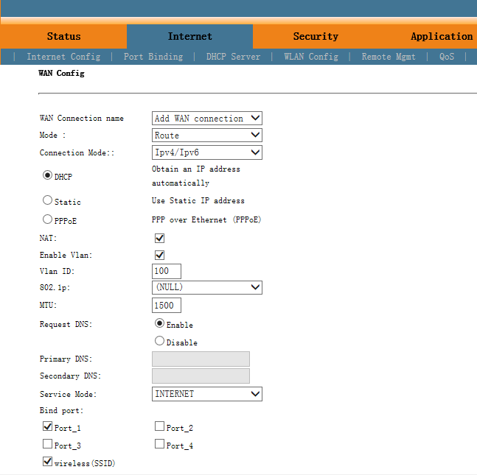

icon-note **NOTE：**

Mode select **Route.** Check **Enable VLAN** and Vlan ID input 100. Service Mode select **INTERNET.** Bind port check **Port_1** and **wireless(SSID).**

Internet service take DHCP mode as an example in this document. The service type please select suitable type according to the user's actual environment. ONT detail usage please refer to ONT user manual.

**2. Check ONU internet wan status**

Click Status🡪Internet Info

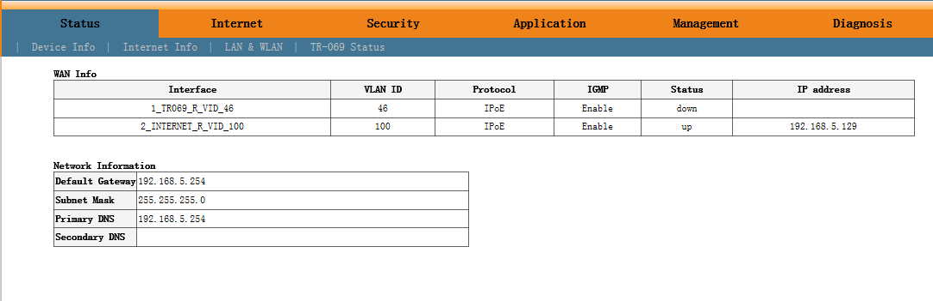

### Configure Gateway ONU（HGU）Multicast Service--RTK Solution

**premise condition**

* OLT connect to uplink device and open multicast service
* OLT have created vlan for multicast
* OLT have configured GE port multicast vlan
* OLT have configured PON port multicast vlan
* ONU have registered

1. **Create bridge wan and bind LAN2 in onu web**

Click Internet🡪Internet Config🡪 WAN Config

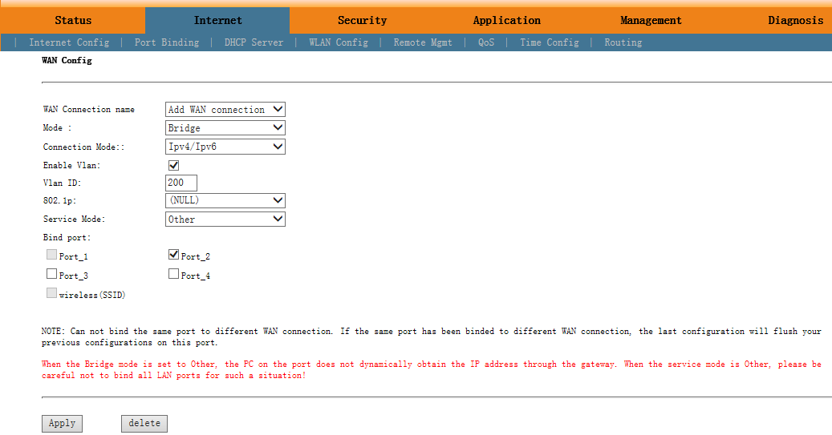

icon-note **NOTE：**

Mode select to **Bridge**. Check **Enable Vlan**,Vlan ID input **200**. Service Mode select **Other**.Bind port click **Port_2**.

1. **Config IGMP mode in ONU web**

Click Application🡪 IGMP Config🡪 IGMP Snooping. Enable IGMP Snooping.

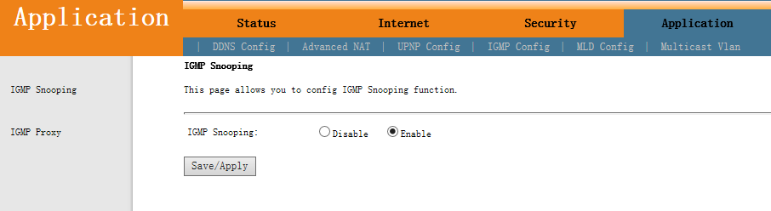

**3.Configure multicast vlan on ONU web**

Click Application🡪 Multicast Vlan🡪 3_Other_B_VID_200🡪 Modify. Input 200 behind VLAN multicast(blank said set).

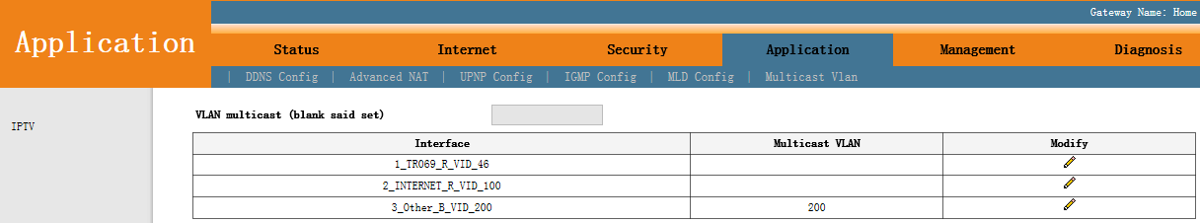

**4.Check ONU multicast wan status**

Click Status🡪Internet Info

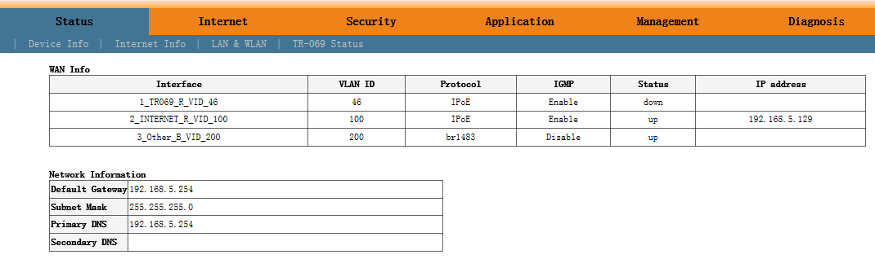

----end

### Configure Gateway ONU（HGU）Internet Service--ZTE Solution

**premise condition**

* OLT connect to uplink device and open internet service
* OLT have created vlan for internet
* OLT have configured GE port vlan
* OLT have configured PON port vlan
* ONU have registered

1. **Create route wan and bind LAN1 in ont web**

Click Network🡪WAN🡪WAN Connection. Type select to DHCP. Connection Name select to Create WAN Connection. Port Binding check LAN1 and SSID1. Service List select to INTERNET. VLAN Mode select to Used. VLAN ID enter 100. finally click Create.

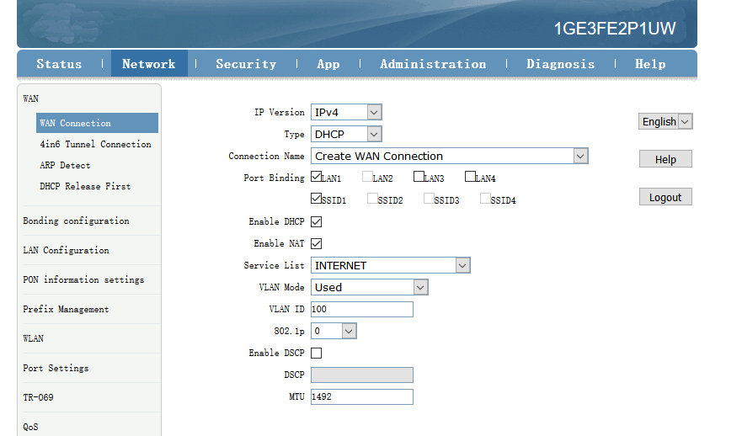

icon-note **NOTE：**

Type select to **DHCP**. Connection Name select to **Create WAN Connection**. Port Binding check **LAN1** and **SSID1**. Service List select to **INTERNET**. VLAN Mode select to **Used**. VLAN ID enter **100**. Enable DHCP and Enable NAT keep default checked status.

In this document,Internet service take DHCP mode as an example.please selected suitable service type according to the user's actual need. ONT detail use way please refer to ONT user manual.

1. **Check ONT internet wan status**

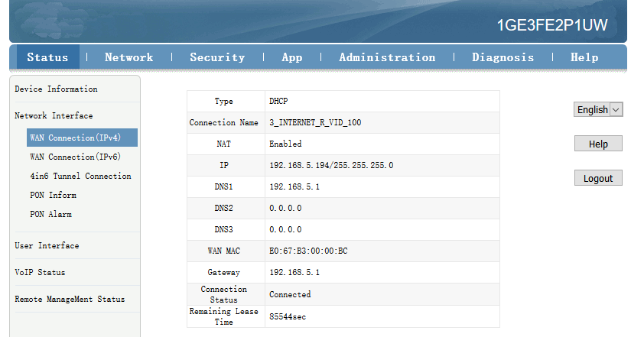

---end

### Configure Gateway ONU（HGU）Multicast Service--ZTE Solution

**premise condition**

* OLT connect to uplink device and open multicast service
* OLT have created vlan for multicast
* OLT have configured GE port multicast vlan
* OLT have configured PON port multicast vlan
* ONU have registered

1. **Create bridge wan in ont web**

Click Network🡪WAN🡪WAN Connection. Type select to Bridge. Connection Name select to Create WAN Connection. Port Binding check LAN2. Service List select to OTHER. VLAN Mode select to Used. VLAN ID enter 200. Finally click Create.

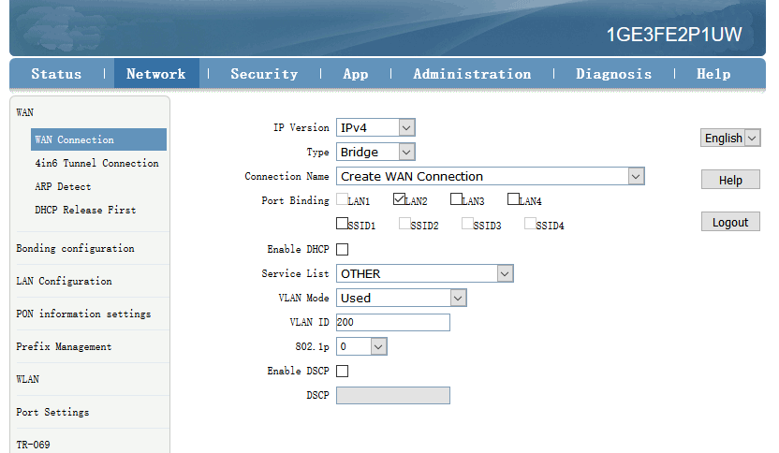

icon-note **NOTE：**

Type select to **Bridge**. Connection Name select to **Create WAN Connection**. Port Binding check **LAN2**. Service List select to **OTHER**. VLAN Mode select to **Used**. VLAN ID enter **200**. Enable DHCP keep default unchecked status.

1. **Check ONT Bridge wan status**

Click Status🡪Network Interface🡪WAN Connection(IPv4).

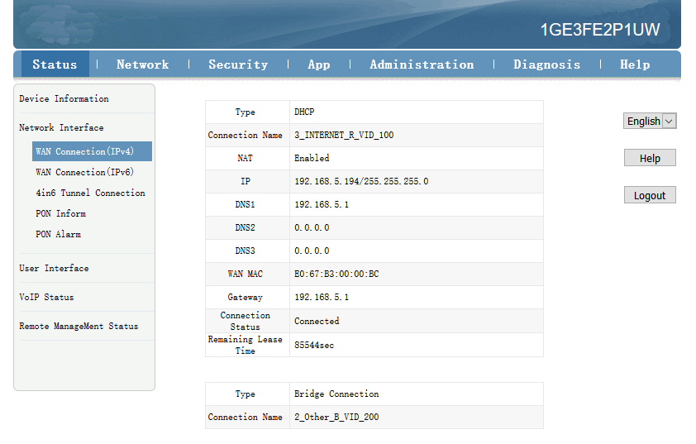

1. **Configure multicast vlan on ONT web**

Click App🡪Normal App🡪IPTV. Modify the Bridge WAN 2_Other_B_VID_200

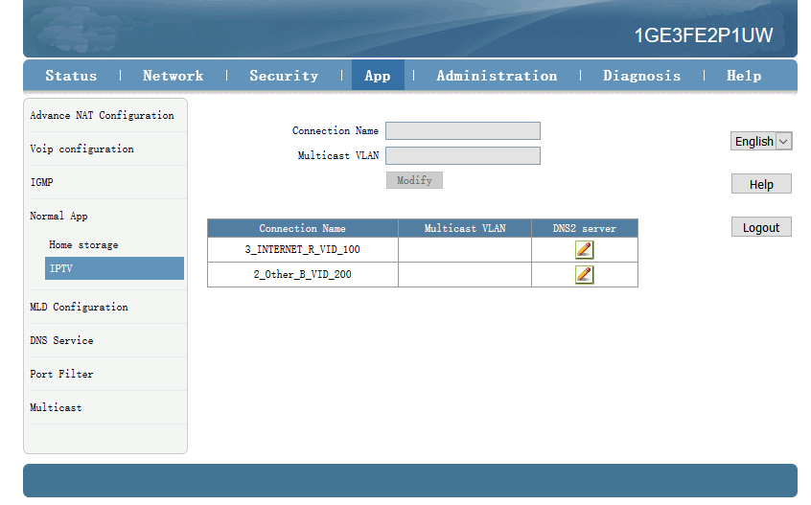

Multicast VLAN enter 200. Then click Modify。

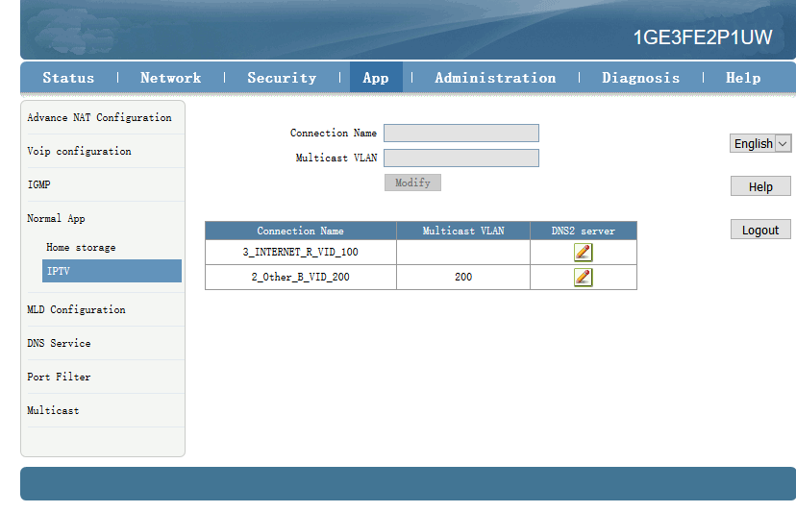

---end

### Configure Gateway ONU（HGU）VOIP Service--ZTE Solution

**premise condition**

* OLT connect to uplink device and open multicast service
* OLT have created vlan for VOIP
* OLT have configured GE port VOIP vlan
* OLT have configured PON port VOIP vlan
* ONU have registered

1. **Configure Voice in ONT web**

Click Network🡪WAN🡪WAN Connection. Type Select to DHCP. Connection Name Select to Create WAN Connection. Service List select to VOICE. VLAN Mode select to Used. VLAN ID enter 300. Finally click Create。

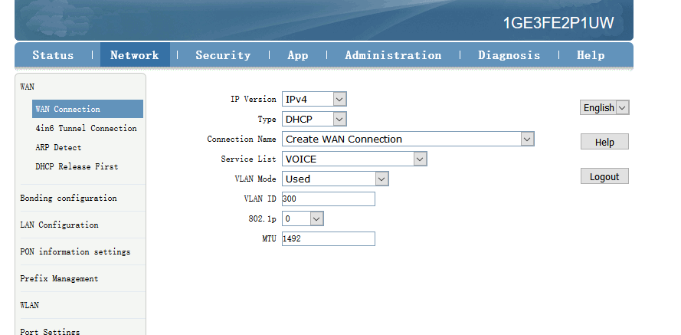

1. **Configure ONT VOIP**

Click App🡪Voip configuration🡪SIP. Enther Sip server ip address.

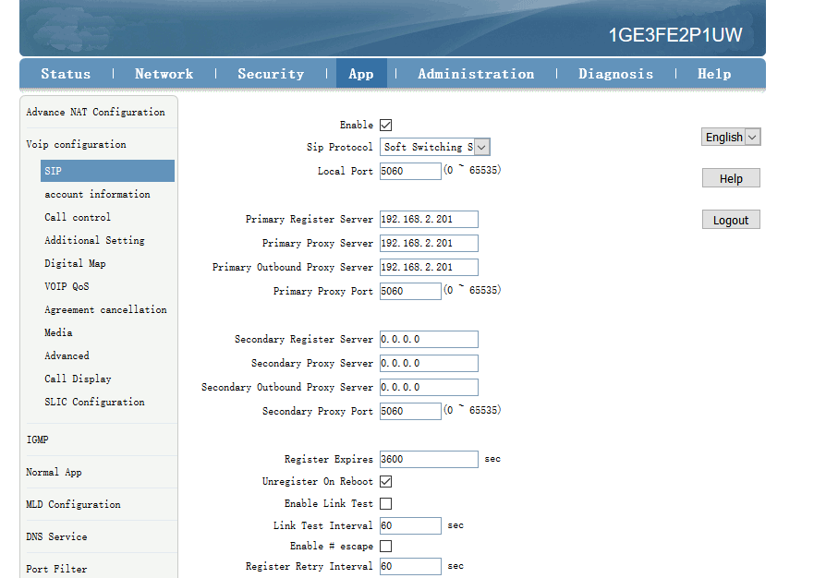

1. **Configure ONT VOIP Account**

Click App🡪Voip Configuration🡪account information. Enther Sip account information.

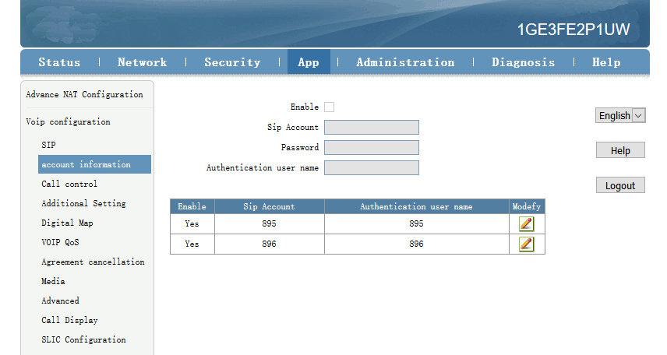

icon-note **NOTE：**

**Sip Account**, **Password**, **Authentication user name** please modify according to the user's actual need.

1. **Check Sip account register status**

Click Status🡪VoIP Status🡪Register Status.

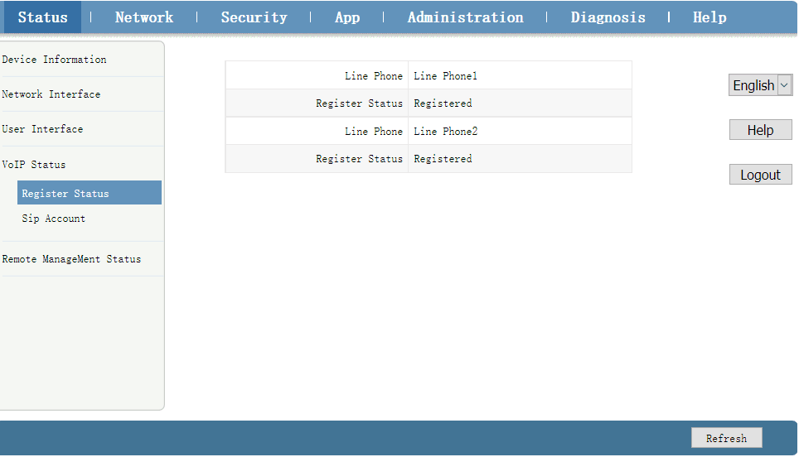

icon-note **NOTE：**

The **Register Status** is Registered mean sip account register successfully.

----end

# Configure Service In OLT Profile Mode---CLI Command Method

This section is mainly introduct FD1204S、FD1208S、FD1216S、FD8000-L116 internet service, voice service and multicast service in profile mode in FTTH environment.we can configure different service profile based on different types of ONU, which can be handled flexibly.Mainly introduce the bridge ONU(SFU) and family gateway ONU (HGU),The following will introduce the service configure way for OLT and ONU according to two types ONU.

## Data Plan

|  |  |
| --- | --- |
| **Main Data Plan List** | |
| **Configure Iteam** | **Data** |
| **OLT Port Config** | **Ge5：** VLAN 100 access mode **Ge6：** VLAN 200 access mode **Ge7：** VLAN 300 access mode **PON1**: VLAN 100, VLAN 200, VLAN 300 trunk mode |
| **DBA Profile（upload**  **bandwidth control）** | **Profile number：** 1 **DBA type：** Type3 **Assure bandwidth：** 8Mbit/s **Max bandwidth**： 20Mbit/s |
| **ONU Lineprofile** | **Profile ID**：1 **LLID：**1 |
| **ONU Srvprofile** | **Profile ID：** 1 **ONU Port Capability**：4 ETH Port， 1 POTS Port |
| **Bridge ONU Port Config** | **LAN 1：** VLAN 100 **LAN 2：** VLAN 200  **LAN 3：** VLAN 300 ---connect to VOIP phone |
| **Gateway ONT Port Config** | **LAN1：** VLAN 100  **LAN2：** VLAN 200  **POTS1：** VLAN 300 |

## Configure Process

End

Create OLT globle vlan

Configure OLT GE port vlan

Configure OLT PON port vlan

Create DBA profile

Save OLT configuration

Start

Create ont srvprofile

[Register](http://dict.youdao.com/w/register/" \l "keyfrom=E2Ctranslation) ONU,and bind

lineprofile and srvprofile

Create ont lineprofile

## Configure OLT Service

### Configfure OLT Globle Vlan

In **config** mode,we can use **OLT(config)# show vlan all** to show the created vlan.

If the created vlan can’t meet the need,we can use command **OLT(config)# vlan** vlan-list to create new vlan,According to the data plan, we create vlan100,vlan200,vlan300 firstly:

OLT(config)# **vlan 100**

OLT(config)# **vlan 200**

OLT(config)# **vlan 300**

### Configure OLT GE Port Service Vlan

We can config GE port vlan mode as access,hybrid and trunk,according to our network plan configure different mode, configure way of three mode as follows.

**Configure GE 5、6、7 port vlan mode is access(in this document,GE port connect to PC,so we configure ge port vlan mode as access):**

OLT(config)# **interface ge 0/0**

OLT(config-interface-ge-0/0)# **vlan mode 5-7 access**

OLT(config-interface-ge-0/0)# **vlan access 5 100**

OLT(config-interface-ge-0/0)# **vlan access 6 200**

OLT(config-interface-ge-0/0)#**vlan access 7 300**

OLT(config-interface-ge-0/0)# **exi**t

**Configure GE 5、6、7 port vlan mode is trunk：**

OLT(config)# **interface ge 0/0**

OLT(config-interface-ge-0/0)# **vlan mode 5-7 trunk**

OLT(config-interface-ge-0/0)# **vlan trunk 5 100**

OLT(config-interface-ge-0/0)# **vlan trunk 6 200**

OLT(config-interface-ge-0/0)#**vlan trunk 7 300**

OLT(config-interface-ge-0/0)# **exit**

**Configure GE 5、6、7 port vlan mode is hybrid：**

OLT(config)# **interface ge 0/0**

OLT(config-interface-ge-0/0)# **vlan mode 5-7 hybrid**

OLT(config-interface-ge-0/0)# **vlan hybrid 5 tagged 100**

OLT(config-interface-ge-0/0)# **vlan hybrid 6 tagged 200**

End

Create OLT globle vlan

Configure OLT GE port vlan

Configure OLT PON port vlan

Create DBA profile

Save OLT configuration

Start

Create ont lineprofile

Create ont srvprofile

[Register](http://dict.youdao.com/w/register/" \l "keyfrom=E2Ctranslation) ONU,and bind

lineprofile and srvprofile

OLT(config-interface-ge-0/0)# **vlan hybrid 7 tagged 300**

OLT(config-interface-ge-0/0)# **exit**

### Configure OLT PON Port Service Vlan

We can config PON port vlan mode as access,hybrid and trunk,according to our network plan configure different mode,if message from ONU is untag,we can config PON port vlan mode is access or hybrid untag mode;if message from ONU is tag,we can config PON port vlan mode is trunk or hybrid tag mode; configure way as follows.

**Configure PON1 port vlan mode is access:**

OLT(config)# **interface epon 0/0**

OLT(config-interface-epon-0/0)# **vlan mode 1 access**

OLT(config-interface-epon-0/0)# **vlan access 1 100**

OLT(config-interface-epon-0/0)# **exit**

**Configure PON1 port vlan mode is trunk:（PON port is trunk mode in this document）:**

OLT(config)# **interface epon 0/0**

OLT(config-interface-epon-0/0)# **vlan mode 1 trunk**

OLT(config-interface-epon-0/0)# **vlan trunk 1 100,200,300**

OLT(config-interface-epon-0/0)# **exit**

**Configure PON1 port vlan mode is hybird:**

OLT(config)# **interface epon 0/0**

OLT(config-interface-epon-0/0)# **vlan mode 1 hybrid**

OLT(config-interface-epon-0/0)# **vlan hybrid 1 tagged 100,200,300**

OLT(config-interface-epon-0/0)# **exit**

### Configure OLT Multicast Service

**Configure IGMP and multicast-vlan 200**

OLT(config)# **igmp mode snooping**

OLT(config)# **multicast-vlan 200**

OLT(config-multicast-vlan-200)# **igmp program add program-index 1 ip 224.3.3.3**

OLT(config-multicast-vlan-200)# **igmp router-port ge 0/0/6**

OLT(config-multicast-vlan-200)# **btv**

OLT(config-btv)# **igmp user add user-index 1 pon 0/0/2 ont 2 vlan 1000 no-auth**

OLT(config-btv)# **multicast-vlan 200**

OLT(config-multicast-vlan-200)# **igmp member user-index 1**

OLT(config-multicast-vlan-200)# **exit**

icon-note **NOTE：**

**igmp program add program-index** command is used to create multicast program table. Only the program table in the multicast vlan, the user can watch the program. Create multicast program table can use **igmp program add program-index <1-2000> batch** command to batch add program or use **igmp program add program-index <1-2000> ip** command to add program single.

## Create ONU Profile

EPON ONU profile include DBA-profile,ont-lineprofile,ont-srvprofile.

* DBA profile:DBA profile describes the EPON flow parameters,the LLID bind DBA profile to [distribute](http://dict.youdao.com/w/distribute/" \l "keyfrom=E2Ctranslation) bandwidth [dynamically](http://dict.youdao.com/w/dynamically/" \l "keyfrom=E2Ctranslation),and increases utilization of uplink bandwidth.
* ont-lineprofile:ont-lineprofile describes the bind relationship of LLID and DBA profile,FEC mode,QOS mode and so on.
* ont-srvprofile:ont-srvprofile provides a service configuration channel for ONU manage by oam.such as ONU port vlan configure,ONU igmp configure.

### Create ONU DBA Profile

Use **show dba-profile all** command to query the existing DBA profile in the system,if the existing DBA profile can’t meet the demand,we need use dba-profile to add DBA profile.Create different DBA profile for different service type.

**Create dba profile number is 1,type is Type3,assure [bandwidth](http://dict.youdao.com/w/bandwidth/" \l "keyfrom=E2Ctranslation) is 8Mbit/s,max [bandwidth](http://dict.youdao.com/w/bandwidth/" \l "keyfrom=E2Ctranslation) is 20Mbit/s：**

OLT(config)# **dba-profile profile-id 1**

OLT(dba-profile-1)# **type3 assure 8192 max 20480**

OLT(dba-profile-1)# **commit**

OLT(dba-profile-1)# **exit**

**NOTE：**  
DBA based on the entire ONU schedule, we need to select the appropriate bandwidth type and bandwidth size according to the service type and onu users number.  The [summation](http://dict.youdao.com/w/summation/" \l "keyfrom=E2Ctranslation) of fixed bandwidth (fix) and guarantee bandwidth (assure) not surpass the [total bandwidth](http://dict.youdao.com/w/total%20bandwidth/" \l "keyfrom=E2Ctranslation) of PON port.

### Create ONU Lineprofile

Create EPON ONU lineprofile,number is 1,bind to DBA profile 1:

OLT(config)# **ont-lineprofile epon profile-id 1**

OLT(config-epon-lineprofile-1)# **llid 1 dba-profile-id 1**

OLT(config-epon-lineprofile-1)# **commit**

OLT(config-epon-lineprofile-1)# **exit**

### Create ONU Srvprofile

Create EPON ONU **srvprofile,**number is 1,configure ONU ETH port number is 4,POTS port number is 2:

OLT(config)# **ont-srvprofile epon profile-id 1**

OLT(config-epon-srvprofile-1)# **ont-port eth 4 pots 2**

OLT(config-epon-srvprofile-1)# **commit**

OLT(config-epon-srvprofile-1)# **exit**

//finish config,use commit command to make [parameter](http://dict.youdao.com/w/parameter/" \l "keyfrom=E2Ctranslation) effect

## Add ONU Manually

**1. Modify PON port ONU authentication method is manually registered with MAC.**

OLT(config)# **interface epon 0/0**

OLT(config-interface-epon-0/0)# **ont authmode 1 mac**

**2.Open pon port ONU automatic find function:**

OLT(config)# **interface epon 0/0**

OLT(config-interface-epon-0/0)#**ont autofind 1 enable**

OLT(config-interface-epon-0/0)#**show ont autofind 1**

//This command show all unregistered ONT information that is connected to the EPON port by the spectrometer.

**3.Register ONU manually and bind lineprofile and srvprofile.**

OLT(config-interface-epon-0/0)# **ont add 1 1 mac-auth E0:67:B3:12:05:3E ont-lineprofile-id 1 ont**

**srvprofile-id 1**

Add pon 1 onu 1 successfully.

OLT(config-interface-epon-0/0)# **ont add 1 2 mac-auth E0:67:B3:09:f0:21 ont-lineprofile-id 1 ont-srvprofile-id 1**

Add pon 1 onu 2 successfully.

**4.Add all the ONU under PON port:**

ont confirm command can be used to add all the ONU under PON port, and also can add ONU separately.：

OLT(config-interface-epon-0/0)# ont confirm 1 all mac-auth ont-lineprofile-id 1 ont-srvprofile-id 1

## Check ONU Registration Status

After adding ONU, use **show ont info** command to query the online status of ONU, and ensure that the ”Control flag” of ont is “Active”, ”Run State” is ”Online”, ”Config state” is “Success” and ”Match state” is ”Match”.

OLT(config-interface-epon-0/0)# show ont info 1 all

-----------------------------------------------------------------------------

F/S P ONT MAC Control Run Config Match Desc

ID flag state state state

----------------------------------------------------------------------------

0/0 1 1 E0:67:B3:09:F0:21 active online success match

0/0 1 2 E0:67:B3:12:05:3E active online success match

-----------------------------------------------------------------------------

Total: 2, online 2

**When the ONU configuration status is failed, ONU cannot up:**

* If the “Control flag” is “deactive”,we need to use ont activate command to activate ONU in EPON mode.
* If the ONU not online, the “Run state” is “offline”, it may be a physical line break, or optical module is damaged, so we need to check all device and the physical line.
* If the ONU “config state” is “failed”, it means ONU’s configuration is not applicable to some configuration of srvprofile, we need to capture packet on the ONU and analyze onu not accept which configuration.
* If the ONU “Match state” is “Mismatch”, it shows that onu srvprofile capability(port number) don't Match ONU practical capability,we can use **show ont capability** and **show ont config - capability to** contrast ONU practical ability and onu srvprofile capability.

## Configure Bridge ONU（SFU）Service

### Configure Bridge ONU(SFU) Internet Service

**premise condition of ONU to open internet service:**

* OLT connect to uplink device and open internet service
* OLT have created vlan for internet
* OLT have configured GE port vlan
* OLT have configured PON port vlan
* ONU have registered and bind to lineprofile and srvprofile

SFU ethernet port vlan mode have transparent,tag(access),trunk mode and so on,we can configure vlan in srvprofile mode or discrete mode(note：If we configure onu port vlan in srvprofile and discrete mode,the discrete configuration priority is higher than the profile configuration,when ONU port discrete configuration vlan is transparent,will apply profile configuration),#4.5 show the discrete configuration, profile config is introduced as follows we can according to our network plan configure different vlan mode,configure way as follows:

**Configure ONU port vlan mode is tag(access) (ONU port vlan mode is tag in this document):**

OLT(config)# **ont-srvprofile epon profile-id 1**

OLT(config-epon-srvprofile-1)# **port native-vlan eth 1 100**

OLT(config-epon-srvprofile-1)# **commit**

OLT(config-epon-srvprofile-1)# **exit**

**Configure ONU port vlan mode is transparent:**

OLT(config)# **ont-srvprofile epon profile-id 1**

OLT(config-epon-srvprofile-1)# **port vlan eth 1 transparent**

OLT(config-epon-srvprofile-1)# **commit**

OLT(config-epon-srvprofile-1)# **exit**

**Configure ONU port vlan mode is trunk:**

OLT(config)# o**nt-srvprofile epon profile-id 1**

OLT(config-epon-srvprofile-1)# **port vlan eth 1 100**

OLT(config-epon-srvprofile-1)# **commit**

OLT(config-epon-srvprofile-1)# **exit**

### Configure Bridge ONU(SFU) IPTV Service

**Premise condition of ONU to open internet service:**

* OLT connect to uplink device and open internet service
* OLT have created vlan for IPTV
* OLT have configured GE port IPTV vlan
* OLT have configured PON port IPTV vlan
* ONU have registered and bind to lineprofile and srvprofile

we can configure SFU IPTV service in srvprofile mode or discrete mode(note：if we configure onu iptv service in srvprofile and discrete mode,the discrete configuration priority is higher than the profile configuration,when ONU iptv service in discrete configuration is default,will apply profile configuration),#4.5 show the discrete config, profile config is introduced as follows,we can according to our network plan configure different vlan mode,configure way as follows:

**Configure ONU port multicast mode ,multicast vlan,[process mode](http://dict.youdao.com/w/process%20mode/" \l "keyfrom=E2Ctranslation) of multicast vlan**

OLT(config)# **interface epon 0/0**

OLT(config-interface-epon-0/0)#**ont multicast-mode 1 1 igmp-snooping**

OLT(config-interface-epon-0/0)# **exit**

OLT(config)# **ont-srvprofile epon profile-id 11**

OLT(config-epon-srvprofile-11)# **port eth 1 multicast-tagstrip untag**

OLT(config-epon-srvprofile-11)# **port multicast-vlan eth 1 200**

OLT(config-epon-srvprofile-11)# **commit**

OLT(config-epon-srvprofile-11)# **exit**

----end

## Gateway ONU（HGU）Service Configure Introduction

Gateway ONU(HGU) can provide internet,voice,iptv service for FTTH,support PPPOE dial-up, network address translation (NAT), Internet Group Management Protocol (IGMP), due to the ONU heve route function, so we need configure onu wan and lan in onu web or TR069 server,not need configure ONU port in OLT, OLT don’t support configure ONU route wan, specific configure way can refer to the previous discrete configuration method and the ONU user manual.

# Configure OLT QinQ Service

## Data Plan

|  |  |
| --- | --- |
| **Main Data Plan List** | |
| **Configure Iteam** | **Data** |
| VLAN | SVLAN 400 : QinQ service outer vlan  CVLAN 100-200:QinQ service inner vlan |
| OLT Port Configure | Ge8：VLAN 400 Hybrid mode  PON2：VLAN 400 Hybrid mode |
| Bridge ONT Port Configure | LAN 3：VLAN 100 |
| Gateway ONT Port Configure | LAN 3：VLAN 100 |

## Configure Processes

Create OLT global vlan

Create Ge port vlan

Configure PON port QinQ

Create ONT vlan

Save configuration

Start

End

## Configure OLT

**Create outer vlan：**

Oprate **show vlan all** command can query the existing vlan,If the [existing](http://dict.youdao.com/w/existing/" \l "keyfrom=E2Ctranslation) vlan does not meet the need, we can use vlan command to create outer vlan.

OLT(config)# **vlan 400**

**Configure GE port QinQ outer vlan：**

OLT(config)# **interface ge 0/0**

OLT(config-interface-ge-0/0)#**vlan mode 8 hybrid**

OLT(config-interface-ge-0/0)# **vlan hybrid 8 tagged 400**

OLT(config-interface-ge-0/0)# **exit**

**Configure PON port QinQ outer vlan and PON port QinQ：**

OLT(config)# **interface epon 0/0**

OLT(config-interface-epon-0/0)#**vlan mode 2 hybrid**

OLT(config-interface-epon-0/0)#**vlan hybrid 2 tagged 400**

OLT(config-interface-epon-0/0)# **vlan qinq 2 cvlan-range 1000 2000 400**

OLT(config-interface-epon-0/0)# **exit**

# Common Command Description

|  |  |
| --- | --- |
| **Command** | **Description** |
| interface epon 0/0 | Enter OLT PON board（Apply to  box OLT FD1204S、FD1208S、FD1216S all default is 0/0） |
| OLT(config)# interface epon **0**/ ***<SlotID>***  **Example：**OLT(config)# interface epon 0/1 **---Enter slot 1** | Enter OLT PON board（apply to Plug-in card OLT FD8000-L116） |
| interface ge 0/0 | Enter OLT uplink(ge) board（In default,box OLT all is 0/0） |
| show vlan all | View all vlan in OLT |
| show port vlan ***<Port ID>*** | View OLT uplink(ge) and PON port vlan(The premise is we need enter the board card mode.） |
| show port state ***<Port ID>*** | View OLT uplink port and PON port status（The premise is we need enter the board card mode.） |
| show version | View OLT software version |
| show device | View OLT mode and other information |
| show interface mgmt | View OLT outband Manage IP |
| show interface vlanif brief | View OLT inband Management IP(The premise is we need have vlanif interface) |
| show current-config | View OLT running configuration |
| show saved-config | View OLT have saved configuration |
| show ont info 0/0 ***<Port ID>*** all | View ONU register status in PON port |
| show ont info 0/0 ***<Port ID> <ONT ID>*** | View ONU details information |
| show ont autofind ***<Port ID>*** | View autofind but unregistered ONU in PON port(The premise is we need to enter the PON board mode) |
| show ont optical-info ***<Port ID> <ONT ID>*** | View ONU optical information |
| show ont port state ***<Port ID> <ONT ID>*** eth ***<ONT Port ID>*** | View ONU port status(The premise is we need to enter the PON board mode) |

# Configure Service In OLT Discrete Mode（Non-Template）---EMS Method

This section mainly introduct New 4Port/8Port/16Port/Plug-in 16Port OLT internet service and multicast service in discrete mode in FTTH environment.The following will introduce the service configuration way for OLT and ONU according to the bridge ONU(SFU).

## Data Plan

|  |  |
| --- | --- |
| **Main Data Plan List** | |
| **Configuration Item** | **Data** |
| **VLAN Data** | VLAN 110：Internet Service  VLAN 120：IPTV Service |
| **OLT Port Setting** | Ge5：VLAN 110 access mode  Ge6：VLAN 120 access mode  PON5：VLAN 110, VLAN 120 trunk mode |
| **ONU Register ID** | Bridge ONU ID：9 |
| **Bridge ONU Port config** | LAN 1：VLAN 110  LAN 2：VLAN 120 |

## Configuration Guide

Create OLT Global Vlan

Create OLT GE Port Vlan

Create OLT PON port vlan

Create ONU Port Vlan

Save OLT Configration

Start

End

## Configure OLT Service

### Configure OLT Global Vlan

Click **“Switch Control Card --> Vlan list”** to query the created Vlan.

If the created vlan cannot meet the requirements, vlan can be created by clicking the **Vlan List**. According to the data planning, we create vlan110 and vlan120 firstly:

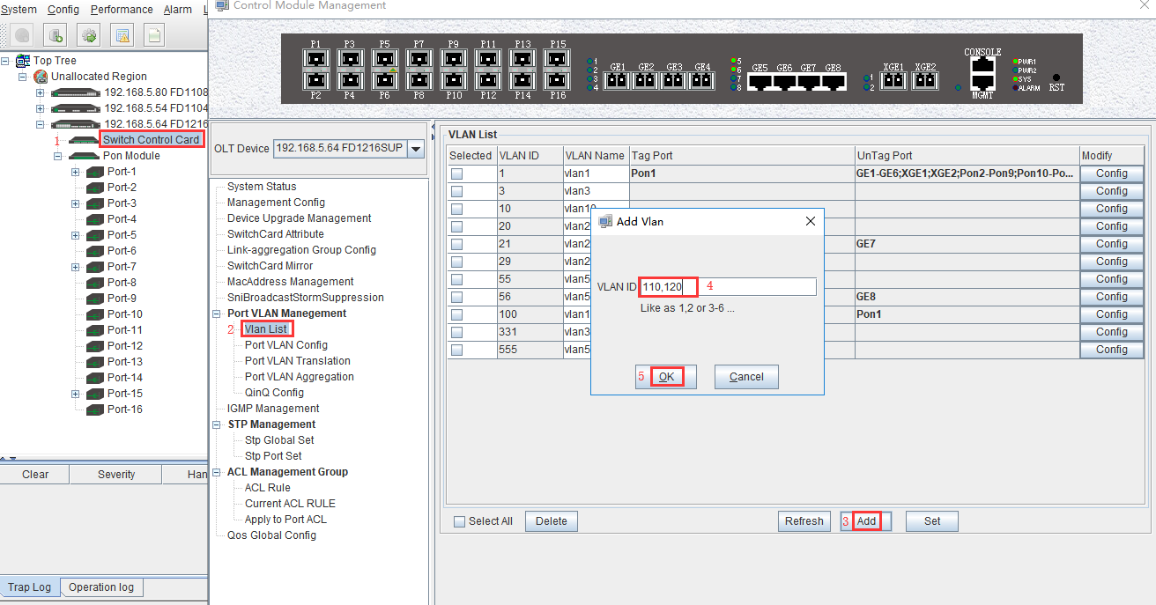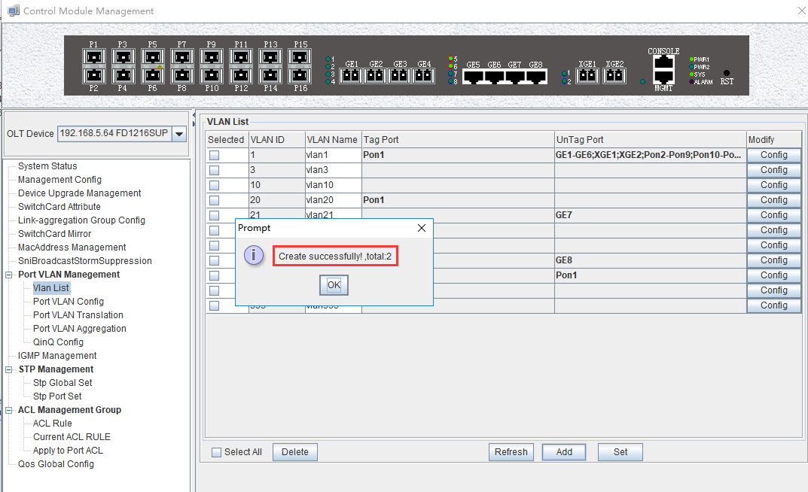

### Configure OLT GE Port Service Vlan

1. Click **“Switch Control Card --> Port VLAN Config”** , and then configure GE 5 port vlan mode is access and add the vlan 110 to the ge5 port :

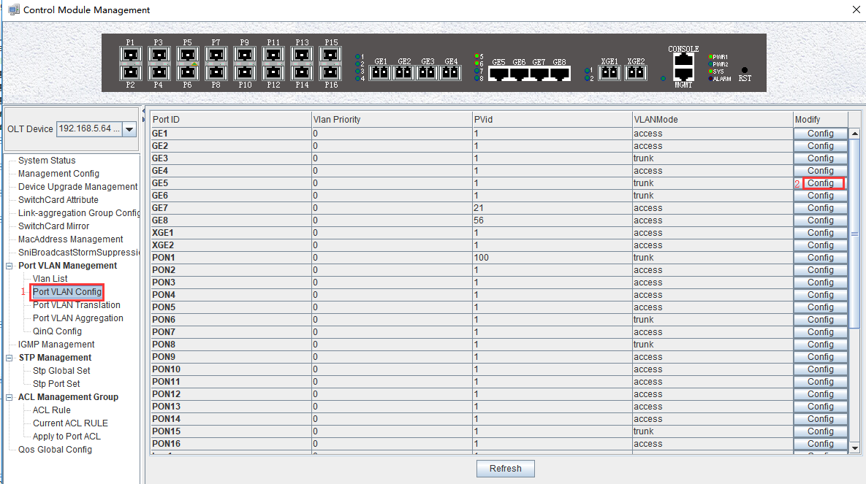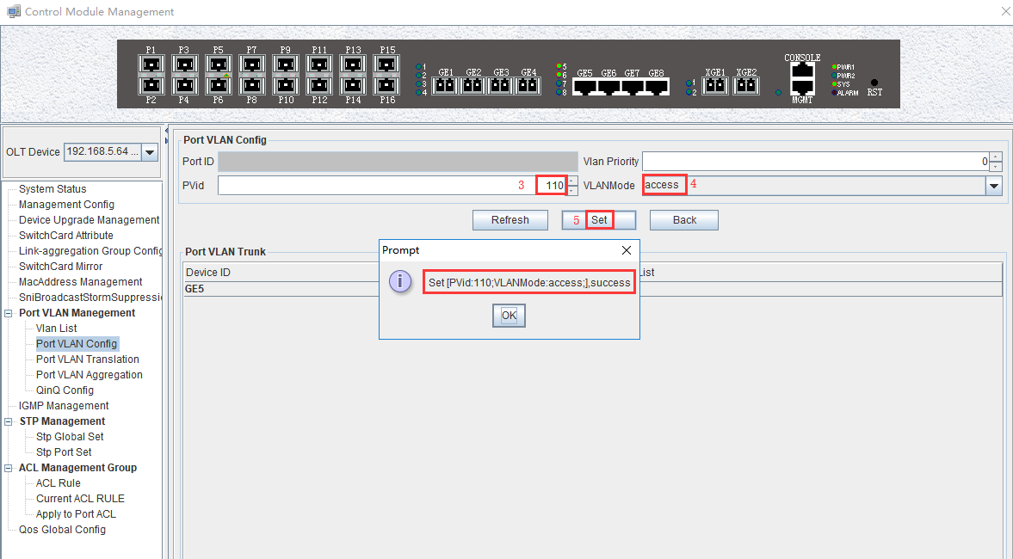

1. Click **“Switch Control Card --> Port VLAN Config”** , and then configure GE 6 port vlan mode is access and add the vlan 120 to the ge6 port :

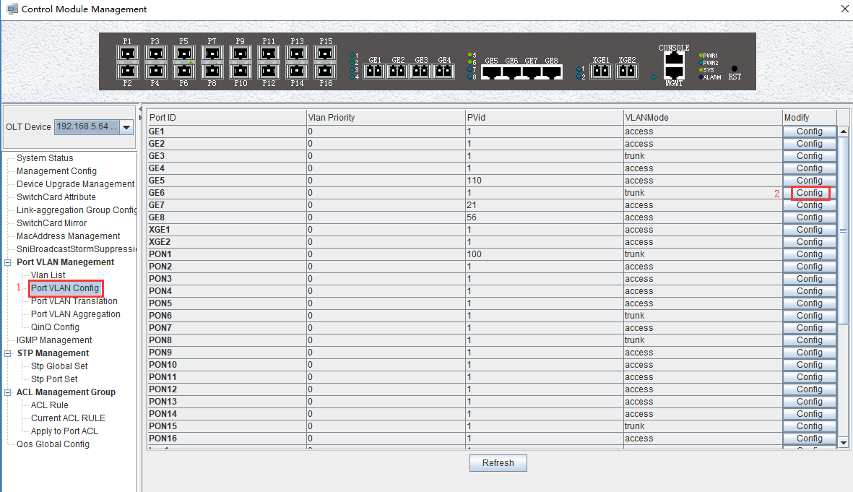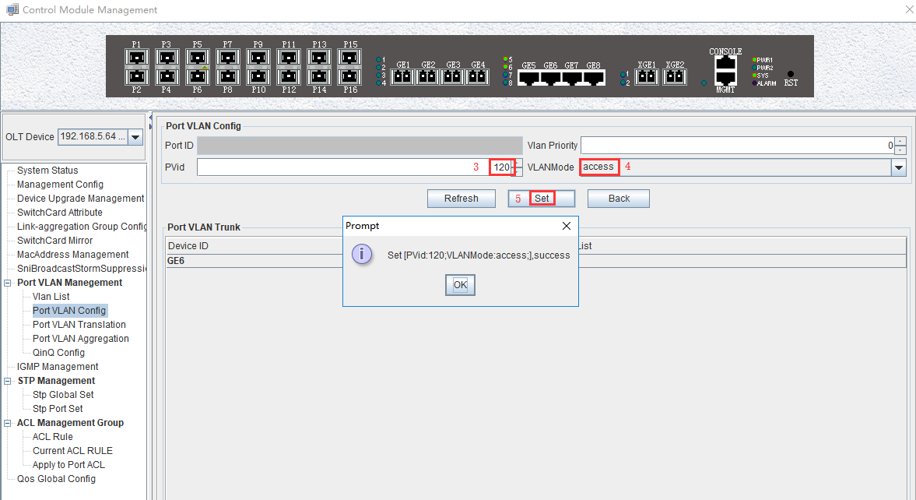

### Configure OLT PON Port Service Vlan

1. Click **“Switch Control Card --> Port VLAN Config --> Config”** , and then config PON5 port vlan mode is trunk:

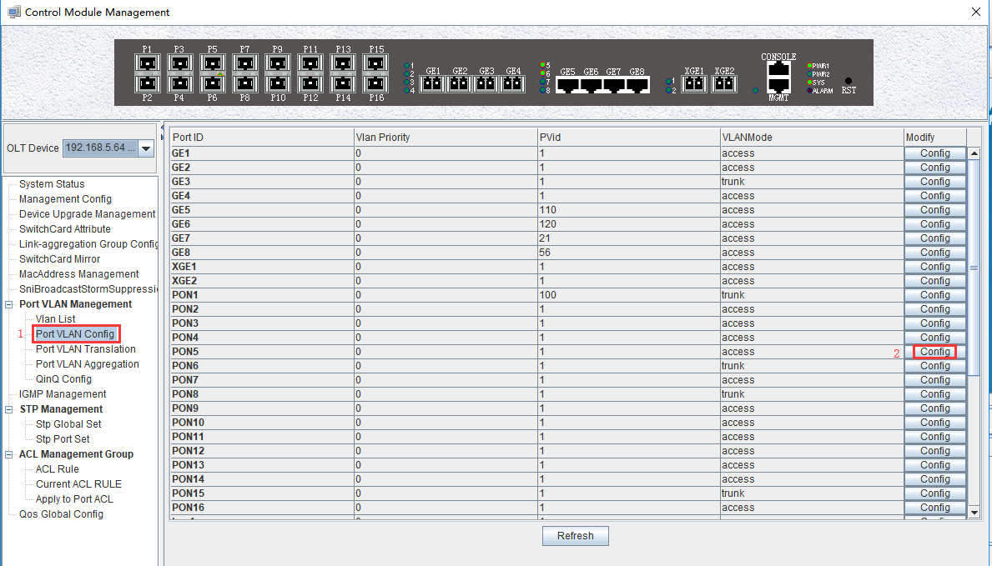

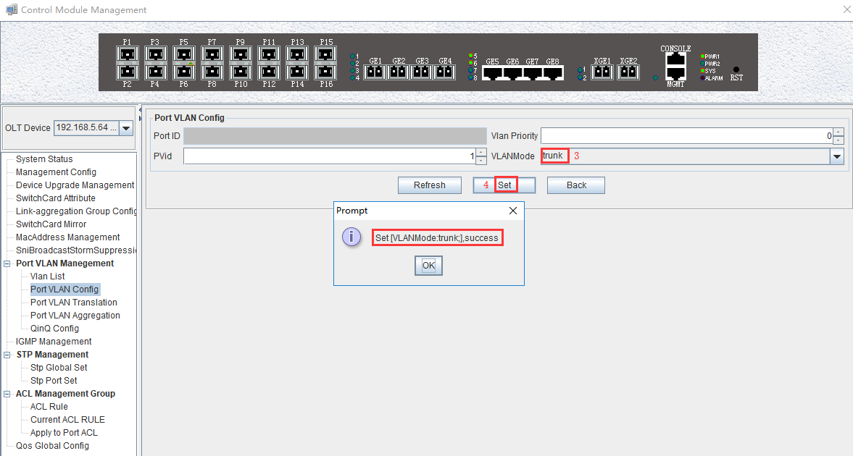

1. Click **“Switch Control Card --> Port VLAN Config --> Config -->Add**” , and then add the vlan 110 and vlan 120 to pon 5 port:

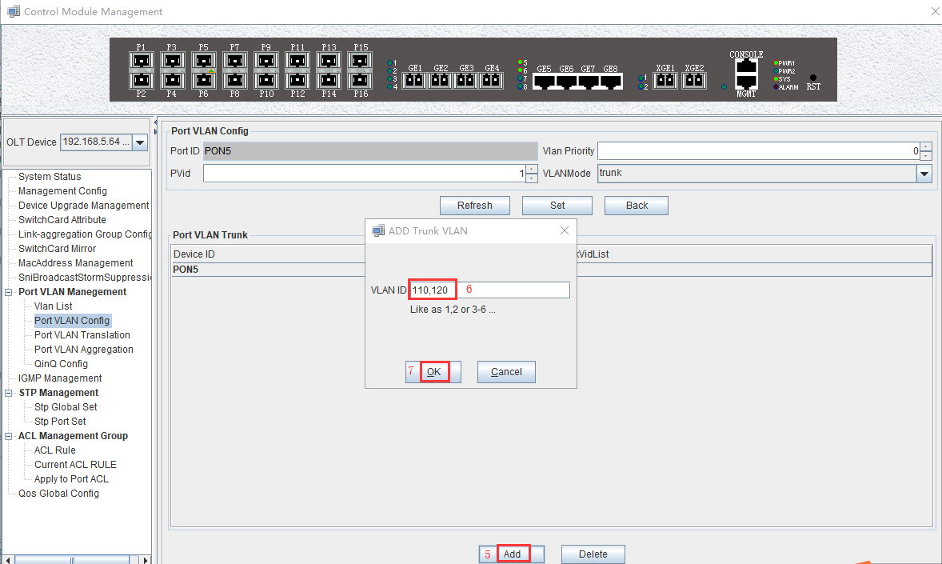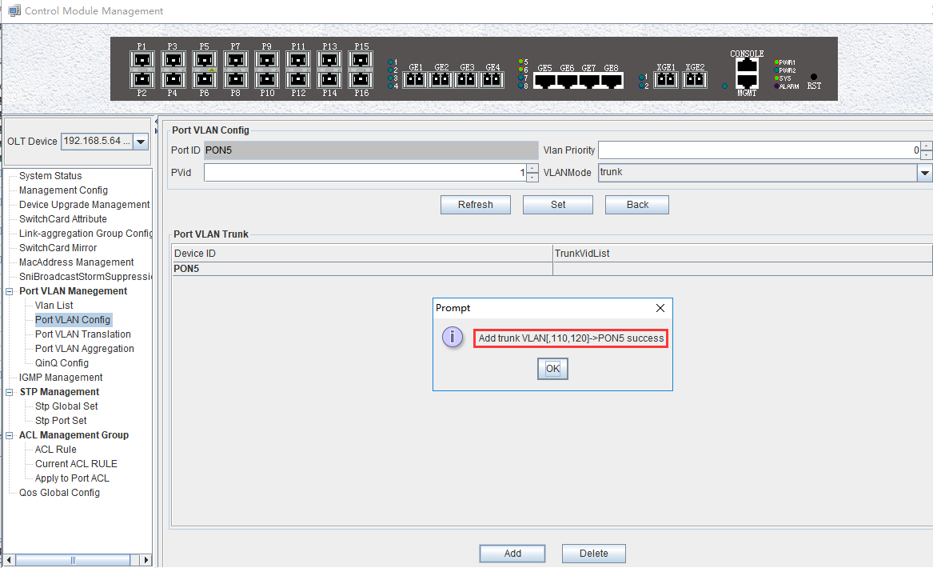

### Configure OLT Multicast Service

1. Click **“Switch Control Card --> IGMP Management”** , and then configure IGMP mode is snooping:

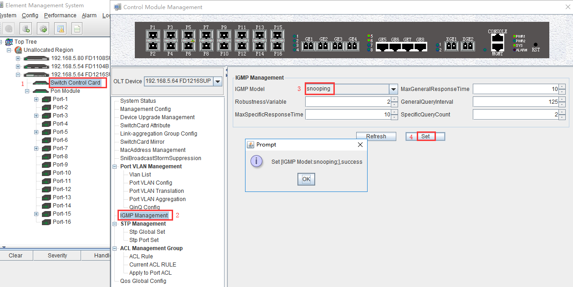

1. Click **“Switch Control Card --> IGMP Management -->Add”** , and then configure IGMP router port is GE6 and multicast vlan is 120:

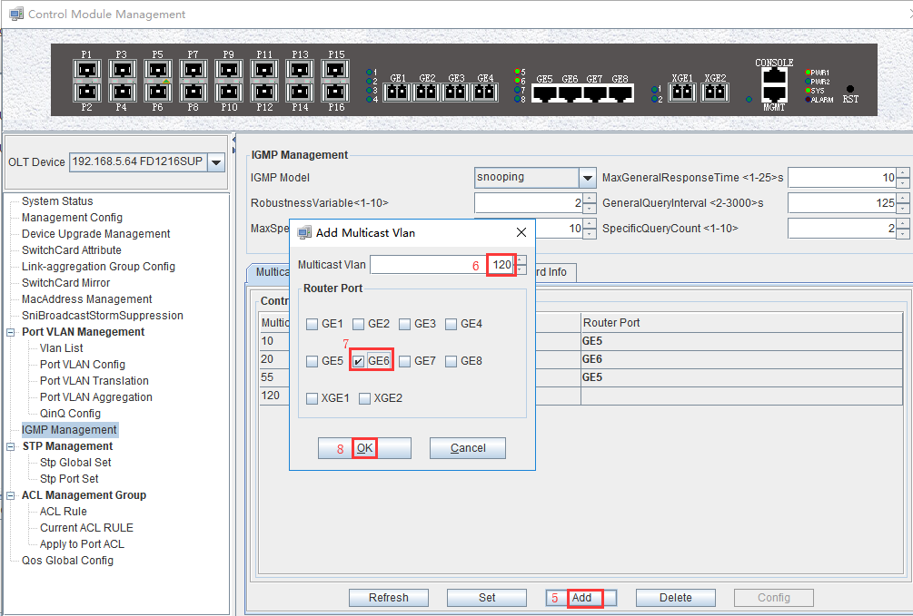

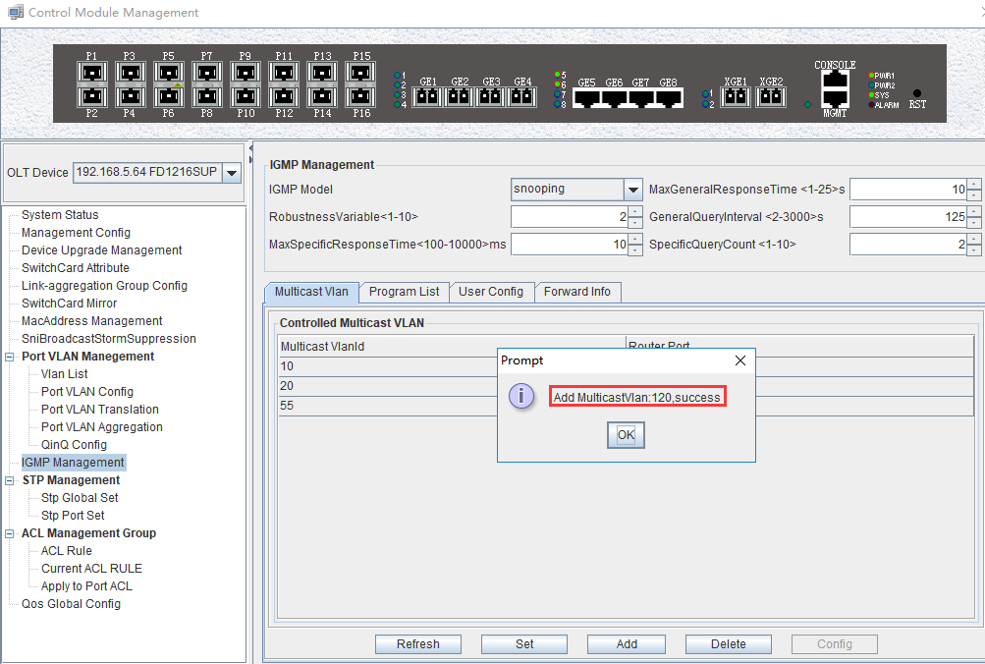

1. Click **“Switch Control Card --> IGMP Management -->Program List”**, and then configure IGMP program id is 1 ,multicast vlan is 120 and multicast address is 224.3.3.3:

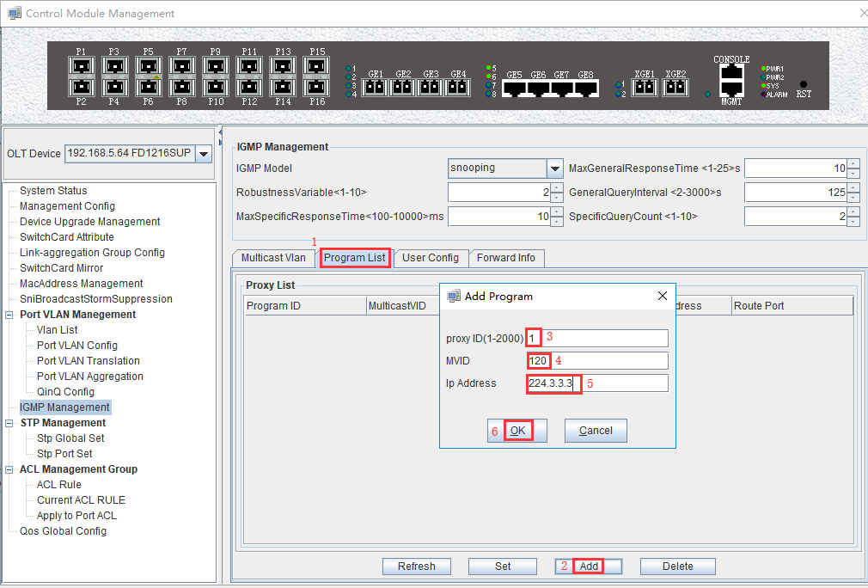

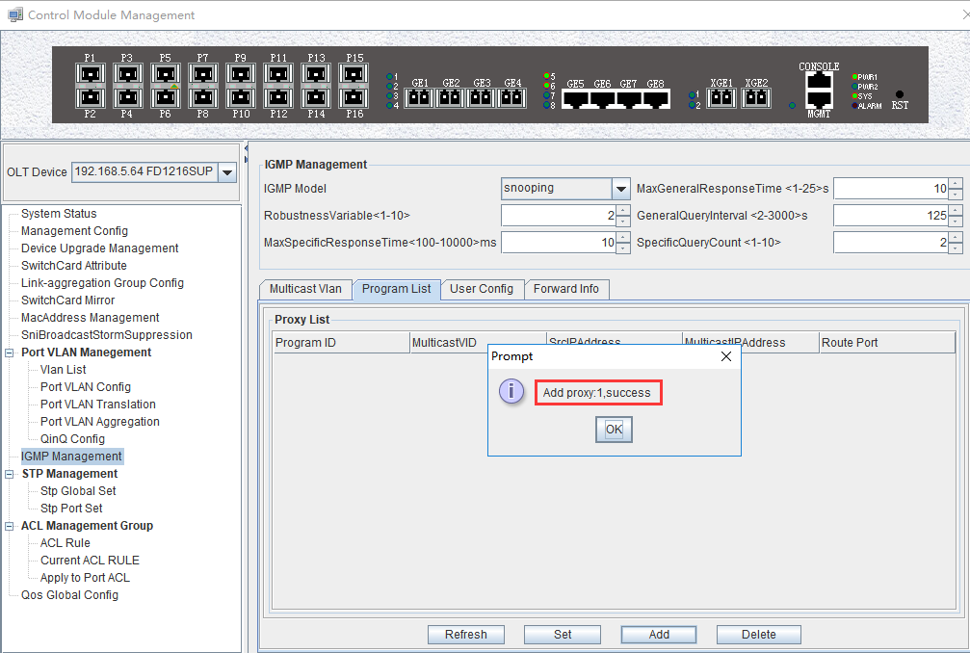

## Configure Bridge ONU(SFU) Service

In OLT discrete mode,we need enter OLT to config ONU one by one,config way as follows:

### Configure Bridge Onu(SFU) Internet Service

**Premise condition of ONU to open internet service:**

* OLT connect to uplink device and open internet service
* OLT have created vlan for internet service
* OLT have configured GE port vlan
* OLT have configured PON port vlan
* ONU have registered

SFU ethernet port vlan mode have transparent,tag(access),trunk mode and so on,we can according to our network plan configure different mode.all onu vlan is configured by OLT,configure way as follows:

1. Click “Pon Module --> Port-5 --> ONU ID9 --> ONU Port VLAN” , and then configure ONU9 eth1 vlan mode is tag(access):

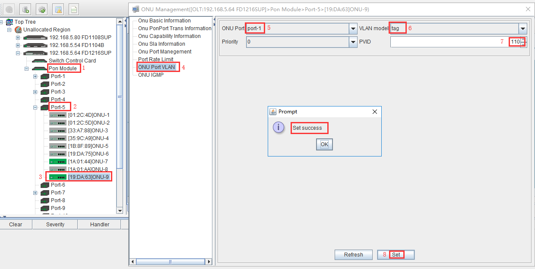

### Configure Bridge Onu(SFU) Multicast Service

**Premise Condition**

* OLT connect to uplink device and open service
* OLT have created vlan for multicast service
* OLT have configured GE port vlan
* OLT have configured PON port vlan
* ONU have registered

In OLT discrete mode,we need enter OLT to config ONU multicast service,configure way as follows:

1. Click **“Pon Module --> Port-5 --> ONU ID 9 --> ONU IGMP”** , and then config ONU9 multicast vlan mode is snooping:

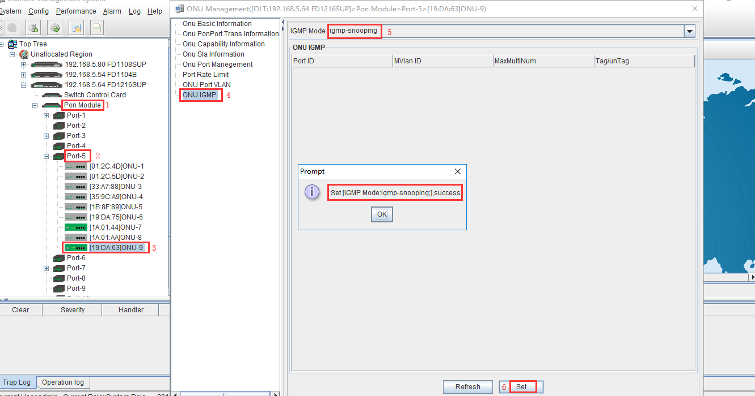

1. Click **“Pon Module --> Port-5 --> ONU ID 9 --> ONU IGMP -->Add”**, and then config ONU9 eth2 vlan is 120:

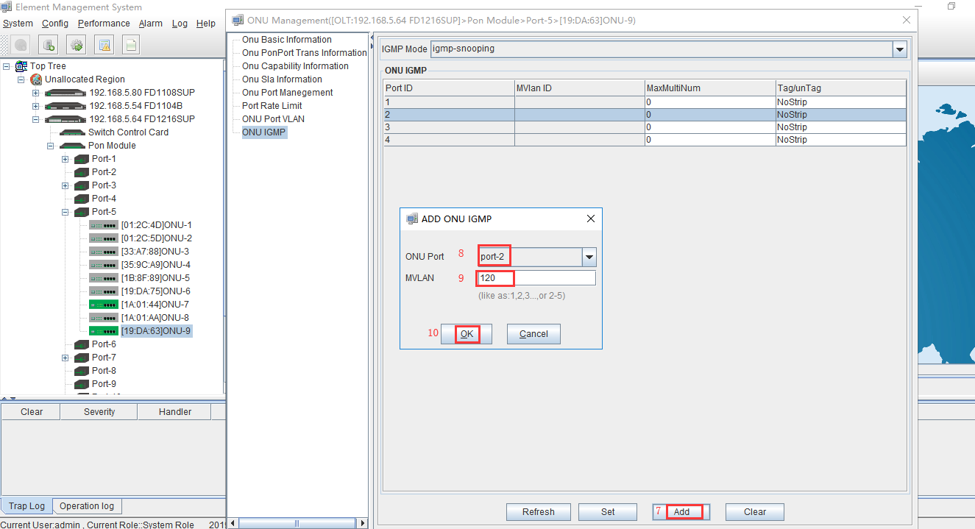

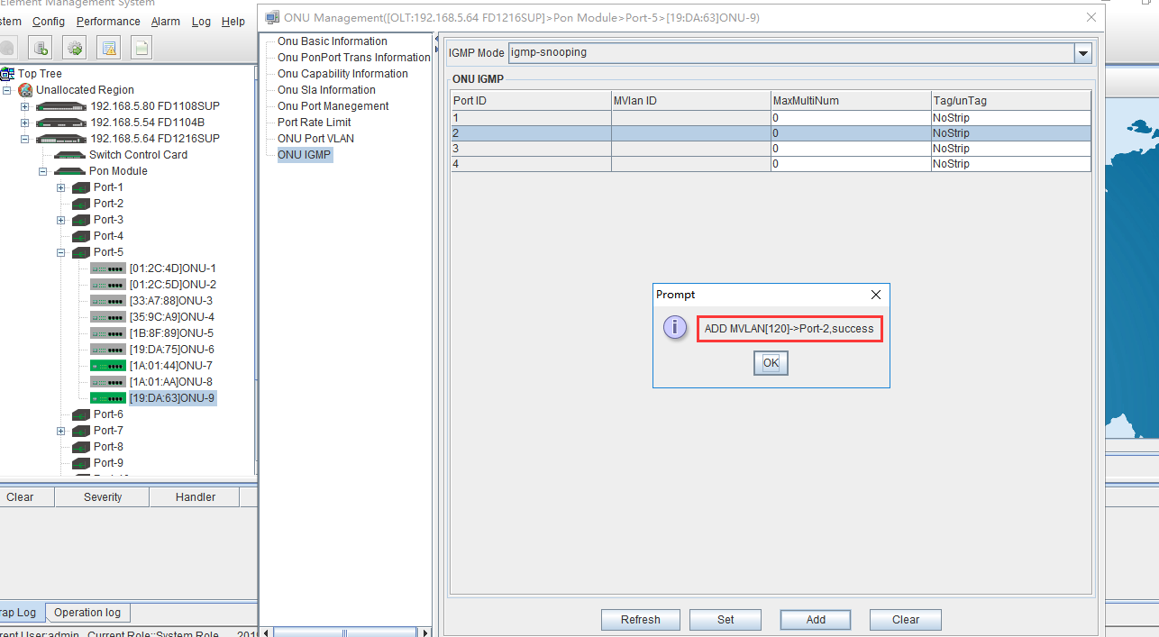

1. Click **“Pon Module --> Port-5 --> ONU ID 9 --> ONU IGMP -->Set”** , and then config multicast vlan mode is strip:

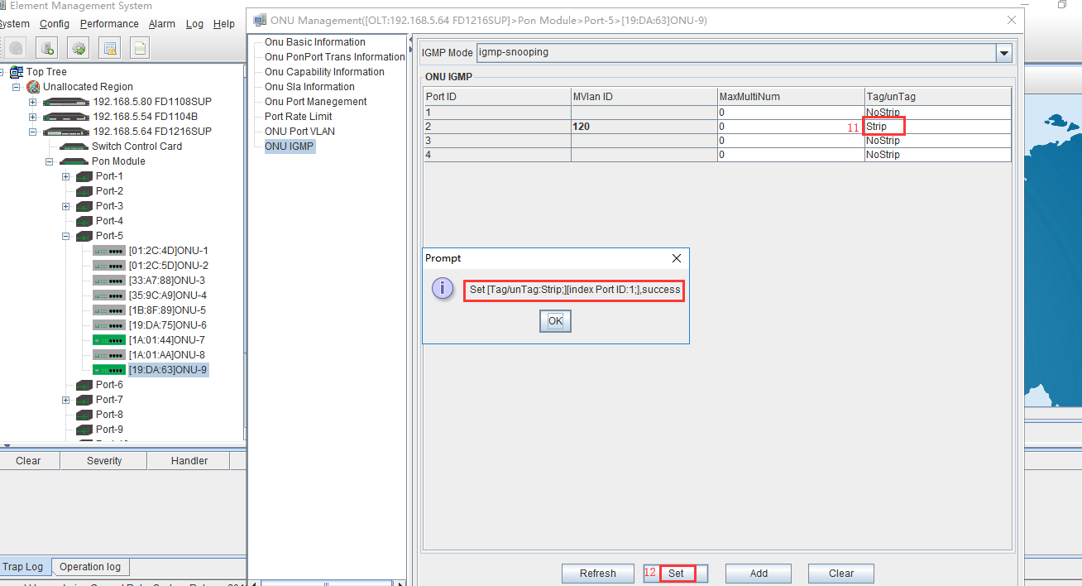

# Configure Service In OLT Discrete Mode（Non-Template）---WEB Method

This section mainly introduct New 4Port/8Port/16Port/Plug-in 16Port OLT internet service and multicast service in discrete mode in FTTH environment.The following will introduce the service configuration way for OLT and ONU according to the bridge ONU(SFU).

## Data Plan

|  |  |
| --- | --- |
| **Main Data Plan List** | |
| **Configuration Item** | **Data** |
| **VLAN Data** | VLAN 110：Internet Service  VLAN 120：IPTV Service |
| **OLT Port Setting** | Ge5：VLAN 110 access mode  Ge6：VLAN 120 access mode  PON5：VLAN 110, VLAN 120 trunk mode |
| **ONU Register ID** | Bridge ONU ID：9 |
| **Bridge ONU Port config** | LAN 1：VLAN 110  LAN 2：VLAN 120 |

## Configuration Guide

Create OLT Global Vlan

Create OLT GE Port Vlan

Create OLT PON port vlan

Create ONU Port Vlan

Save OLT Configration

Start

End

## Configure OLT Service

### Configure OLT Global Vlan

Click the **“Main Board --> Vlan-->Vlan Config”** to query the created Vlan.

If the created vlan cannot meet the requirements, vlan can be created by clicking the **“VLAN --> Vlan Config “.** According to the data planning, we create vlan110 and vlan120 firstly:

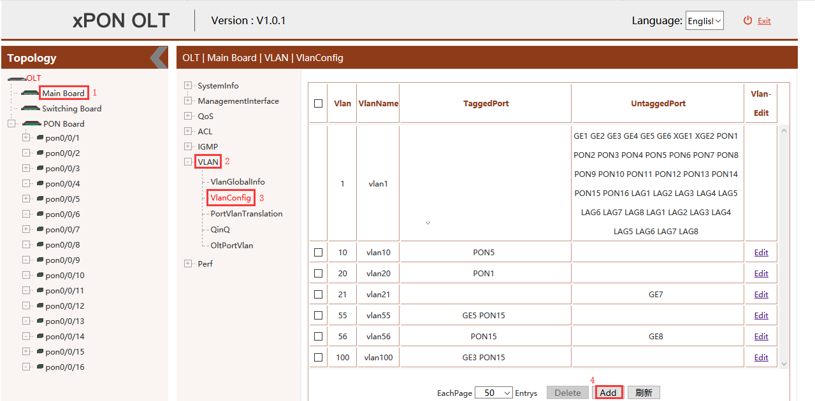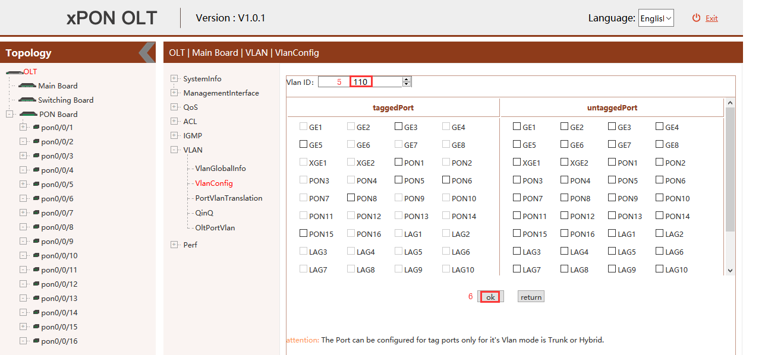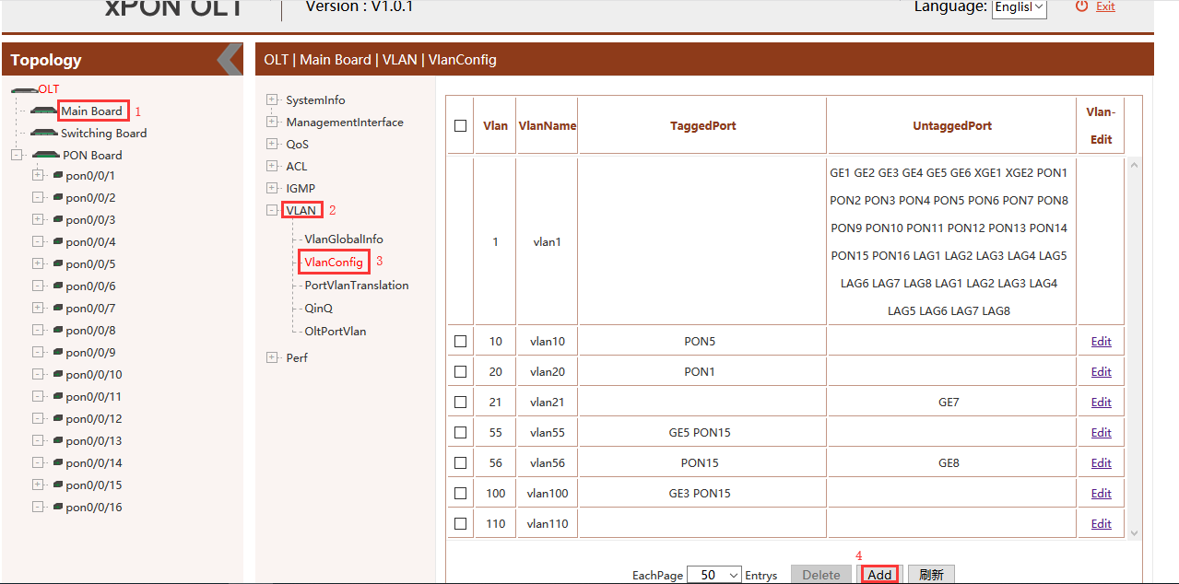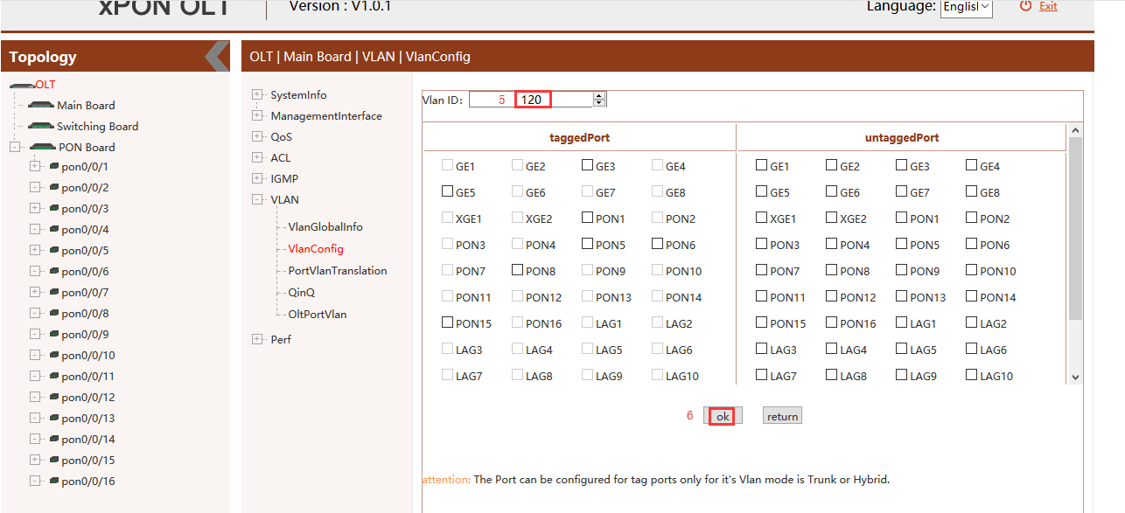

### Configure OLT GE Port Service Vlan

1. Click **“Main Board --> VLAN --> OLT Port Vlan”** ,and then config GE 5 port vlan mode is access, vlan id is 110 :

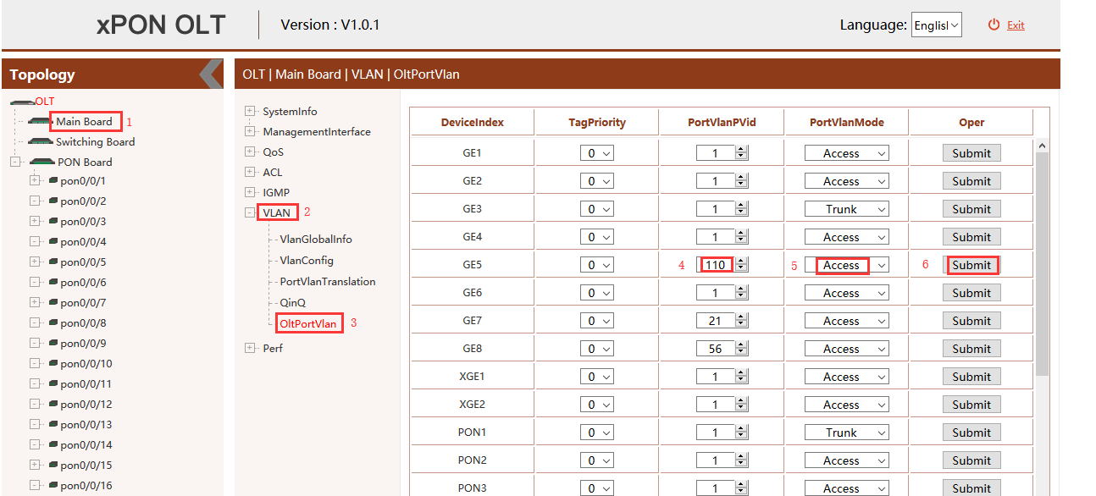

1. Click **“Main Board--> VLAN --> OLT Port Vlan”** ,and config GE 6 port vlan mode is access, vlan id is 120 :

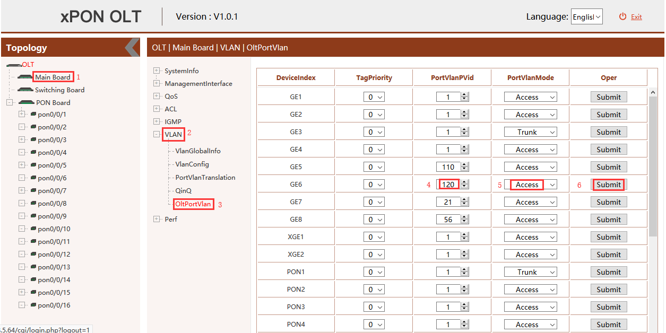

### Configure OLT PON Port Service Vlan

1. Click **“Main Board --> VLAN --> OLT Port Vlan”** , and then Config PON5 port vlan mode is trunk:

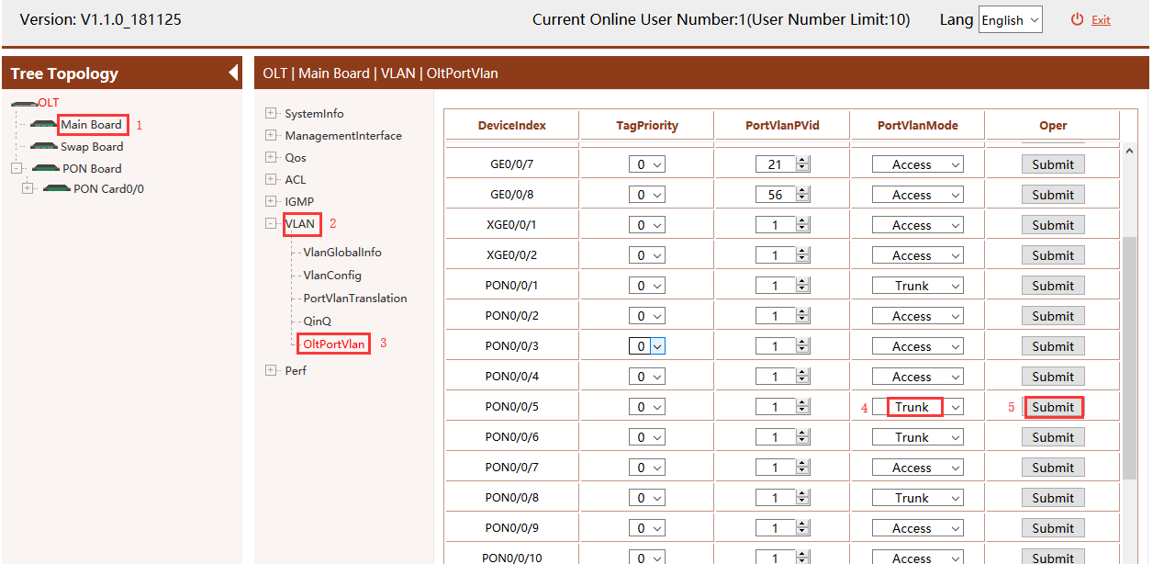

1. Click **“Main Board--> VLAN--> OLT Port Vlan--> (vlan110)Edit”** ,and then add tag vlan 110 to pon 5:

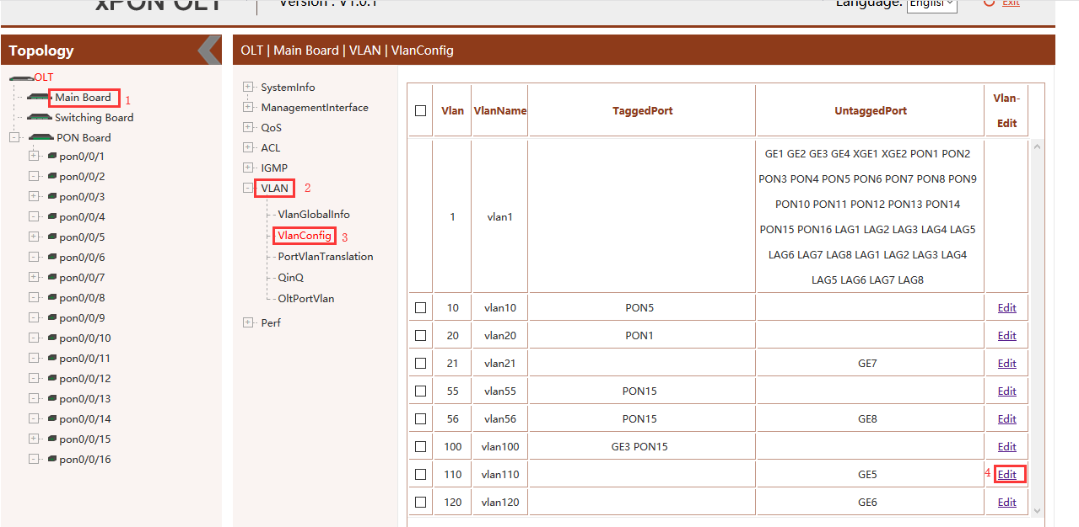

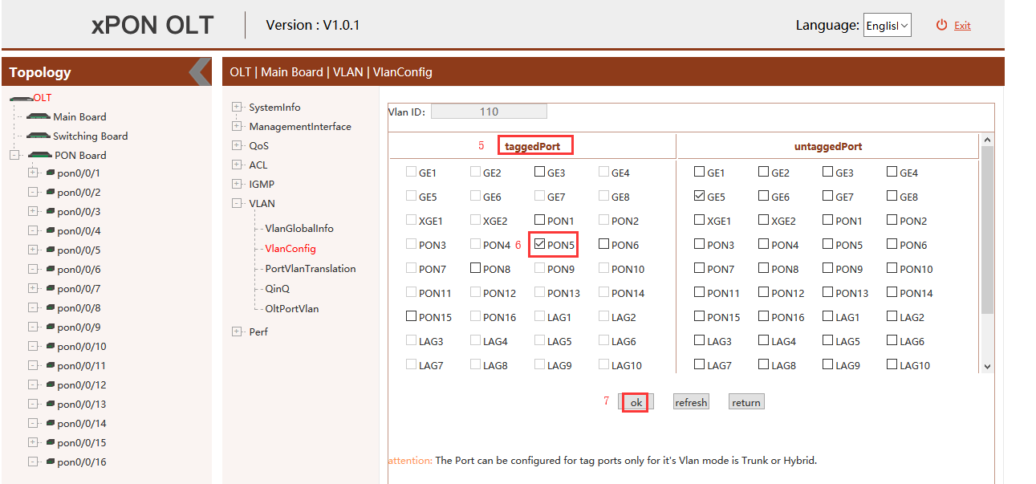

1. Click **“Main Board--> VLAN--> OLT Port Vlan--> (vlan120)Edit”** ,and then add tag vlan 120 to pon 5:

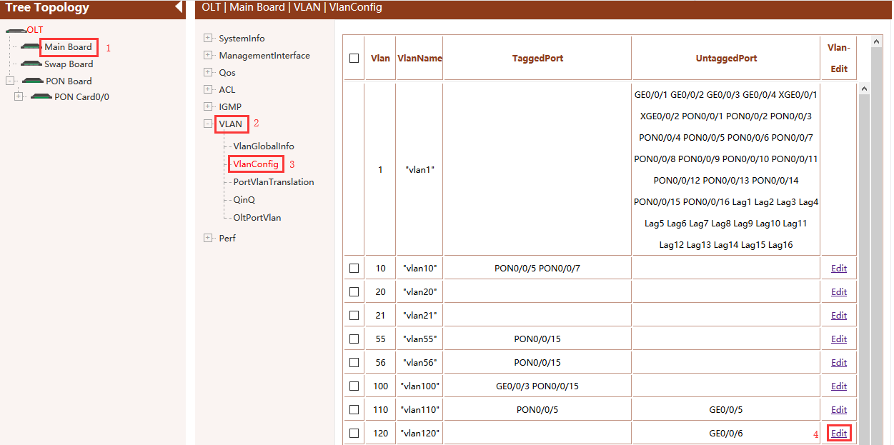

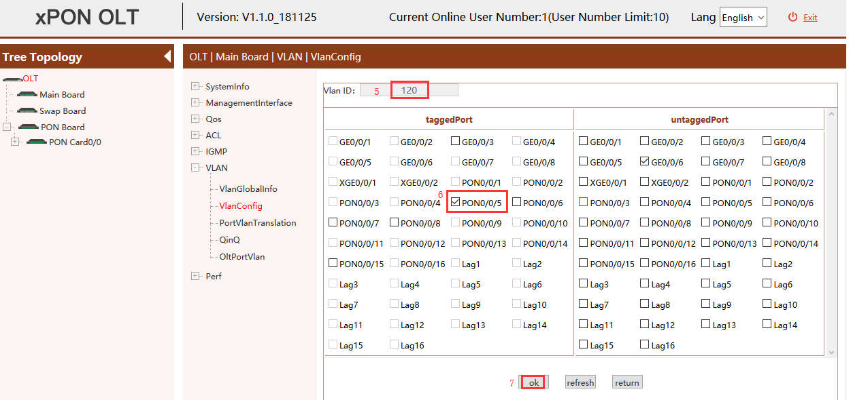

### Configure OLT Multicast Service

1. Click **“Main Board --> IGMP --> IGMP Global Config”** ,and then config IGMP mode is snooping:

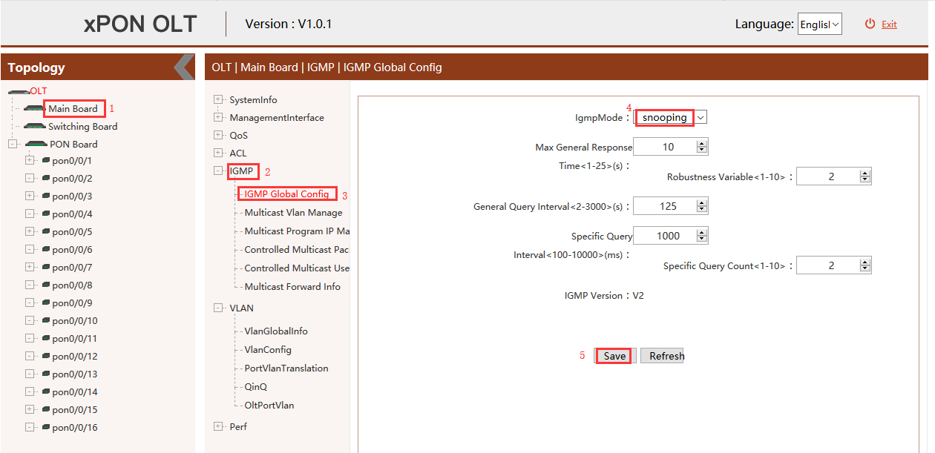

1. Click **“Main Board --> IGMP --> Multicast Vlan Manage --> Add”** ,and then config multicast-vlan is 120 and IGMP route port is ge6 :

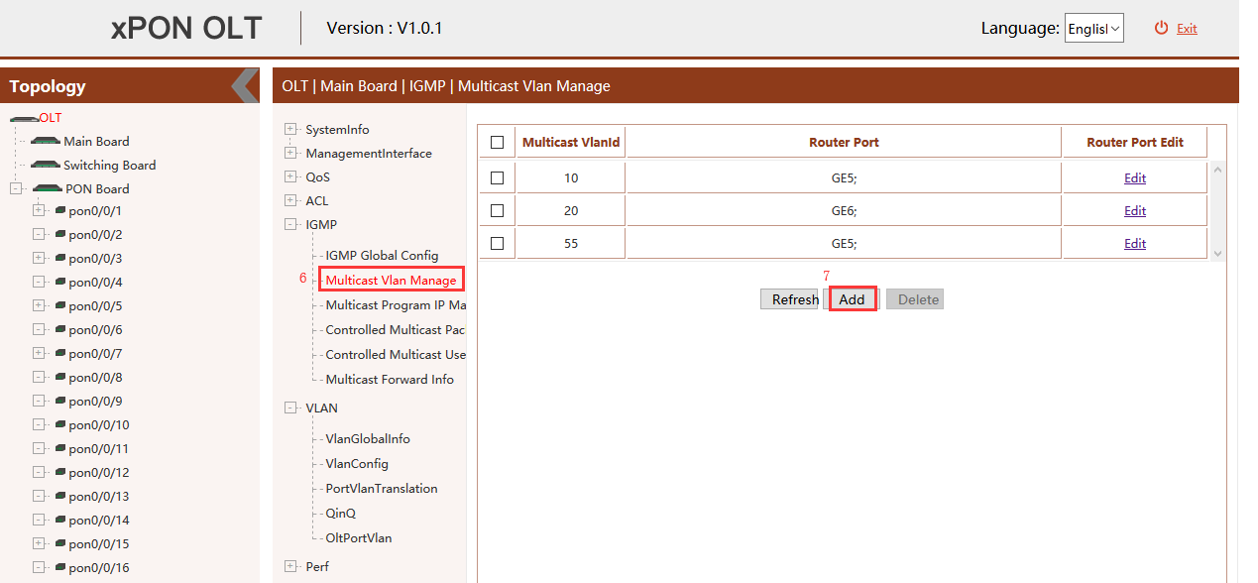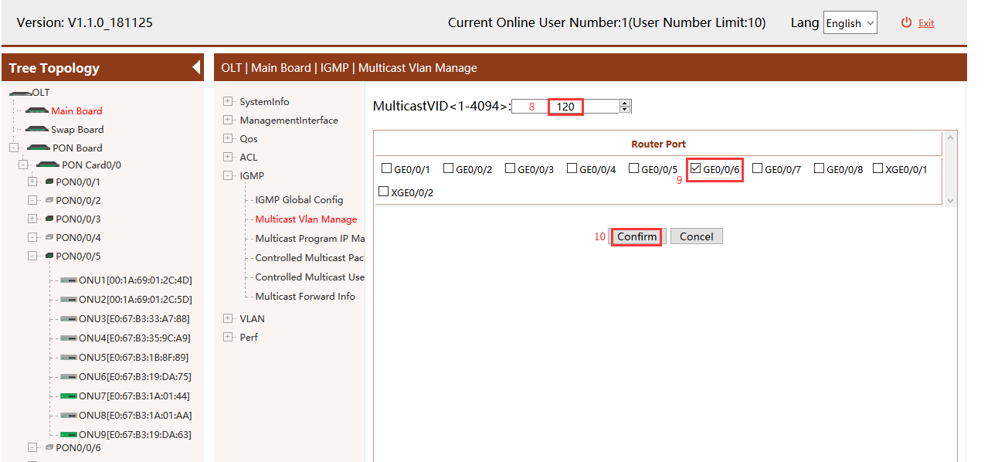

1. Click **“Main Board --> IGMP --> Multicast Program IP Manage --> Add”** ,and then config program id is 1 , multicast-vlan is 120 and program ip is 224.3.3.3 :

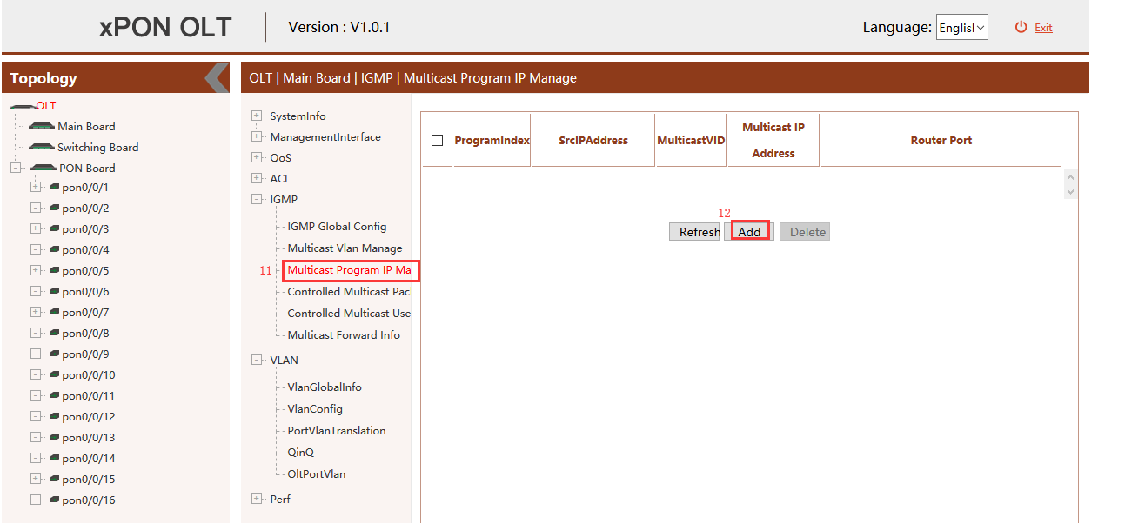

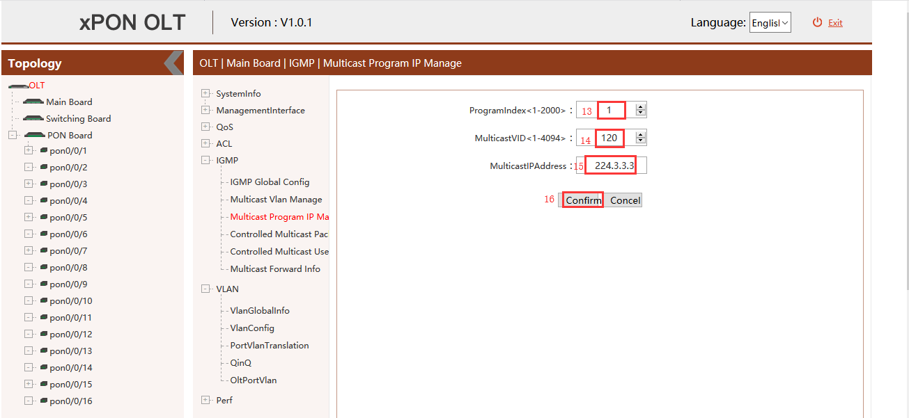

## Configure Bridge ONU(SFU) Service

In OLT discrete mode,we need enter OLT to config ONU one by one,config way as follows:

### Configure Bridge Onu(SFU) Internet Service

**Premise condition of ONU to open internet service:**

* OLT connect to uplink device and open internet service
* OLT have created vlan for internet service
* OLT have configured GE port vlan
* OLT have configured PON port vlan
* ONU have registered

SFU ethernet port vlan mode have transparent,tag(access),trunk mode and so on,we can according to our network plan configure different mode.all onu vlan is configured by OLT,configure way as follows:

1. Click **“PON Control --> PON0/0/5 --> ONU ID 9 --> ONU port --> ONU Port Vlan Table --> Edit”**, Config ONU9 eth1 vlan mode is tag(access):

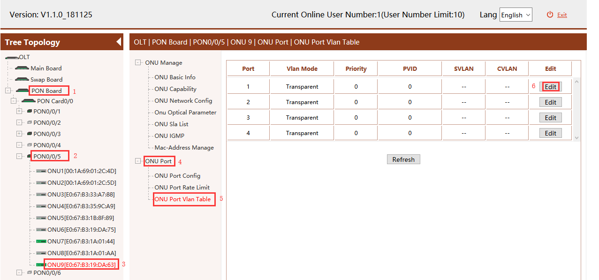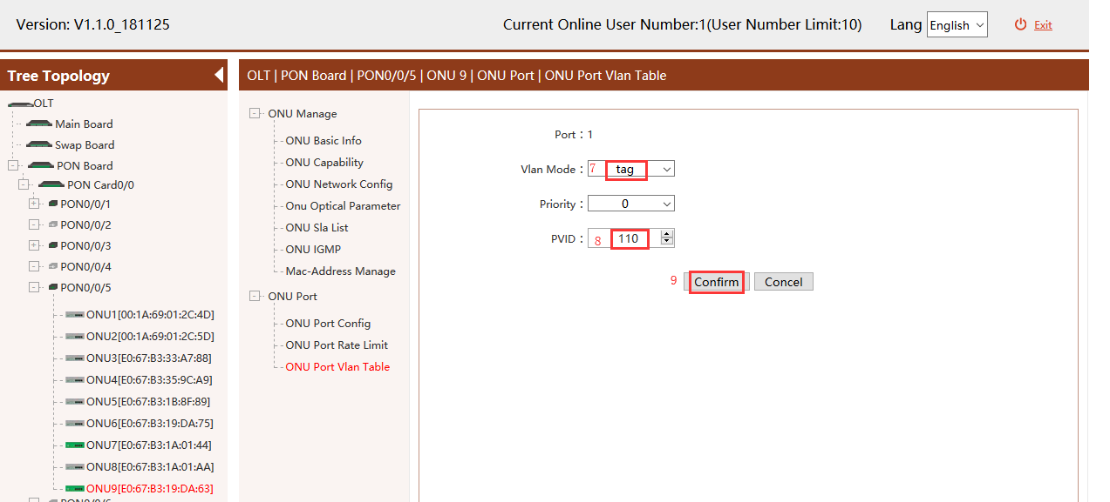

### Configure Bridge Onu(SFU) Multicast Service

**Premise Condition**

* OLT connect to uplink device and open service
* OLT have created vlan for multicast service
* OLT have configured GE port vlan
* OLT have configured PON port vlan
* ONU have registered

In OLT discrete mode,we need enter OLT to config ONU multicast service,configure way as follows:

1. Click **“PON Control --> PON0/0/5 --> ONU ID 9 --> ONU IGMP”**, Configure ONU9 multicast vlan mode is snooping:

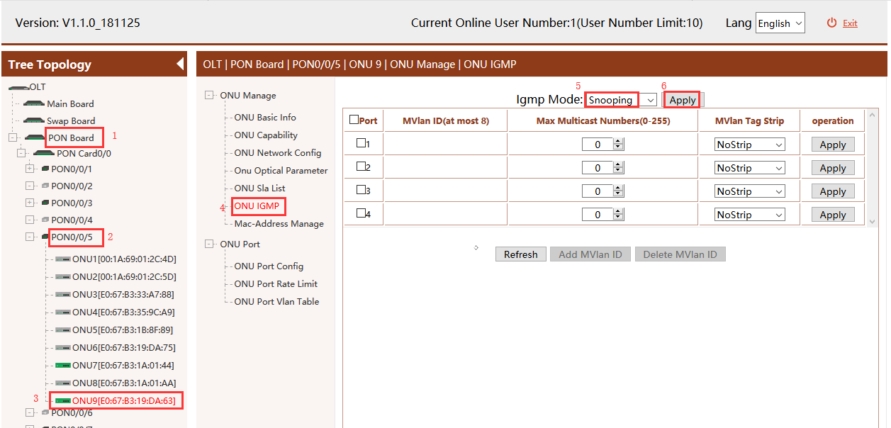

1. Click **“PON Control --> PON0/0/5 --> ONU ID 9 --> ONU IGMP --> Add Mvlan ID”**, Configure ONU9 eth2 vlan is 120, and multicast vlan mode is untag:

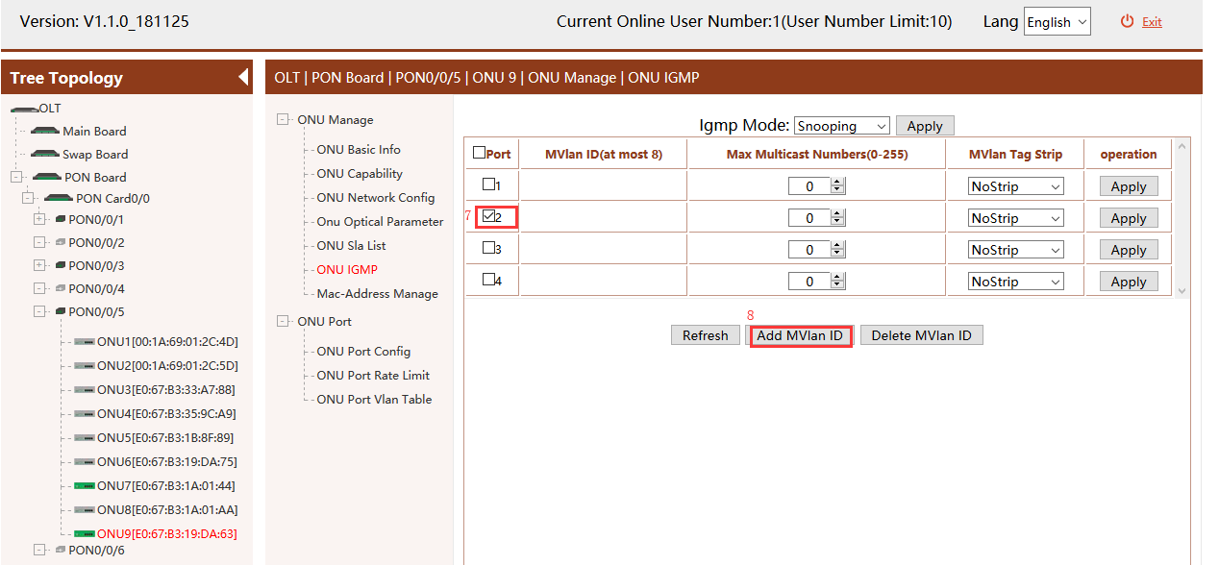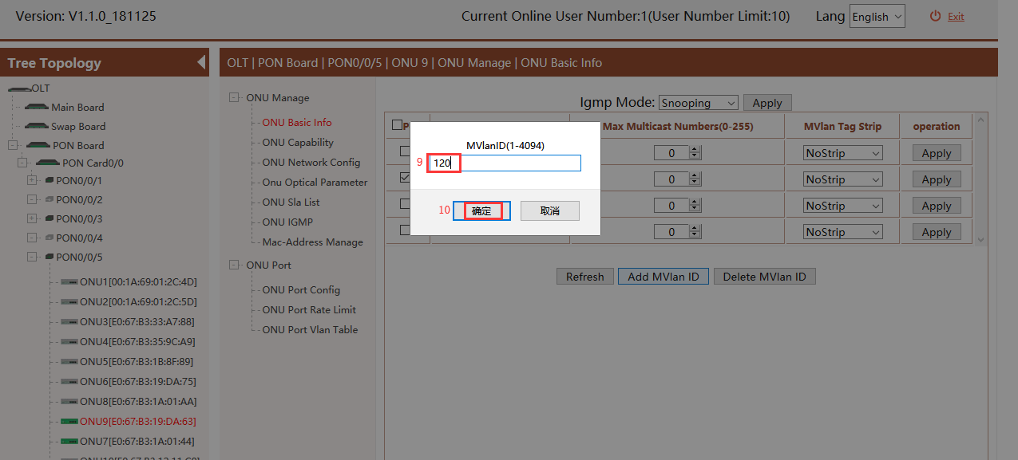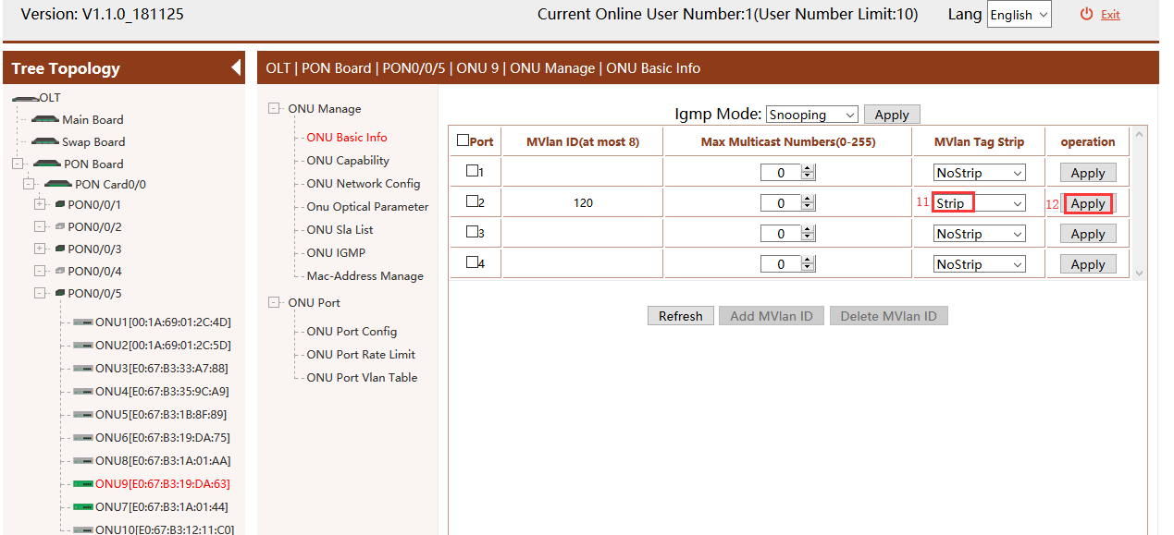

# Concluding Remarks

Thanks for using products of Shenzhen C-Data Technology Co. Ltd.

Contact Information:

Company Address: Room 601, Floor 6, Building F, Songbai Road 1008, Sunshine Community，Xili Street, Nanshan District, Shenzhen, China

Factory Address: 1st floor, Building B, Wentao Industrial Park, Yingrenshi Community, Shiyan Avenue, Baoan District, Shenzhen, China

Telephone: 0755-26014509/26014710/26014711

Fax: 0755-26014506

Email: [Marketing@cdatatec.com](mailto:Marketing@cdatatec.com)

Website: [www.cdatatec.com](http://www.cdatatec.com)

[www.cdatatec.com.cn](http://www.cdatatec.com.cn)